1. DECENTRALIZED ACCESS CONTROL WITH ANONYMOUS AUTHENTICATION OF DATA STORED IN CLOUDS

1.1. INTRODUCTION
What is cloud computing?
Cloud computing is the use of computing resources (hardware and software) that are delivered as a service over a network (typically the Internet). The name comes from the common use of a cloud-shaped symbol as an abstraction for the complex infrastructure it contains in system diagrams. Cloud computing entrusts remote services with a user's data, software and computation. Cloud computing consists of hardware and software resources made available on the Internet as managed third-party services. These services typically provide access to advanced software applications and high-end networks of server computers.
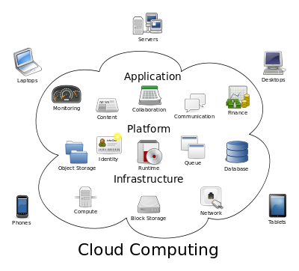
Structure of cloud computing
How Cloud Computing Works?
The goal of cloud computing is to apply traditional supercomputing, or high-performance computing power, normally used by military and research facilities, to perform tens of trillions of computations per second, in consumer-oriented applications such as financial portfolios, to deliver personalized information, to provide data storage or to power large, immersive computer games.
The cloud computing uses networks of large groups of servers typically running low-cost consumer PC technology with specialized connections to spread data-processing chores across them. This shared IT infrastructure contains large pools of systems that are linked together. Often, virtualization techniques are used to maximize the power of cloud computing.

Characteristics and Services Models:
The salient characteristics of cloud computing based on the definitions provided by the National Institute of Standards and Terminology (NIST) are outlined below:
- On-demand self-service: A consumer can unilaterally provision computing capabilities, such as server time and network storage, as needed automatically without requiring human interaction with each service’s provider.
- Broad network access: Capabilities are available over the network and accessed through standard mechanisms that promote use by heterogeneous thin or thick client platforms (e.g., mobile phones, laptops, and PDAs).
- Resource pooling: The provider’s computing resources are pooled to serve multiple consumers using a multi-tenant model, with different physical and virtual resources dynamically assigned and reassigned according to consumer demand. There is a sense of location-independence in that the customer generally has no control or knowledge over the exact location of the provided resources but may be able to specify location at a higher level of abstraction (e.g., country, state, or data center). Examples of resources include storage, processing, memory, network bandwidth, and virtual machines.
- Rapid elasticity: Capabilities can be rapidly and elastically provisioned, in some cases automatically, to quickly scale out and rapidly released to quickly scale in. To the consumer, the capabilities available for provisioning often appear to be unlimited and can be purchased in any quantity at any time.
- Measured service: Cloud systems automatically control and optimize resource use by leveraging a metering capability at some level of abstraction appropriate to the type of service (e.g., storage, processing, bandwidth, and active user accounts). Resource usage can be managed, controlled, and reported providing transparency for both the provider and consumer of the utilized service.
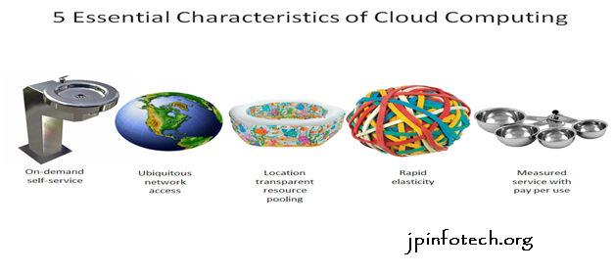
Characteristics of cloud computing
Services Models:
Cloud Computing comprises three different service models, namely Infrastructure-as-a-Service (IaaS), Platform-as-a-Service (PaaS), and Software-as-a-Service (SaaS). The three service models or layer are completed by an end user layer that encapsulates the end user perspective on cloud services. The model is shown in figure below. If a cloud user accesses services on the infrastructure layer, for instance, she can run her own applications on the resources of a cloud infrastructure and remain responsible for the support, maintenance, and security of these applications herself. If she accesses a service on the application layer, these tasks are normally taken care of by the cloud service provider.
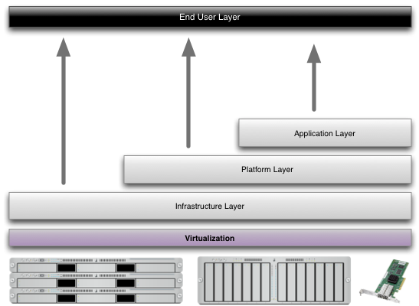
Structure of service models
Benefits of cloud computing:
- Achieve economies of scale – increase volume output or productivity with fewer people. Your cost per unit, project or product plummets.
- Reduce spending on technology infrastructure. Maintain easy access to your information with minimal upfront spending. Pay as you go (weekly, quarterly or yearly), based on demand.
- Globalize your workforce on the cheap. People worldwide can access the cloud, provided they have an Internet connection.
- Streamline processes. Get more work done in less time with less people.
- Reduce capital costs. There’s no need to spend big money on hardware, software or licensing fees.
- Improve accessibility. You have access anytime, anywhere, making your life so much easier!
- Monitor projects more effectively. Stay within budget and ahead of completion cycle times.
- Less personnel training is needed. It takes fewer people to do more work on a cloud, with a minimal learning curve on hardware and software issues.
- Minimize licensing new software. Stretch and grow without the need to buy expensive software licenses or programs.
- Improve flexibility. You can change direction without serious “people” or “financial” issues at stake.
Advantages:
- Price: Pay for only the resources used.
- Security: Cloud instances are isolated in the network from other instances for improved security.
- Performance: Instances can be added instantly for improved performance. Clients have access to the total resources of the Cloud’s core hardware.
- Scalability: Auto-deploy cloud instances when needed.
- Uptime: Uses multiple servers for maximum redundancies. In case of server failure, instances can be automatically created on another server.
- Control: Able to login from any location. Server snapshot and a software library lets you deploy custom instances.
- Traffic: Deals with spike in traffic with quick deployment of additional instances to handle the load.

1.2.ABSTRACT
We propose a new decentralized access control scheme for secure data storage in clouds that supports anonymous authentication. In the proposed scheme, the cloud verifies the authenticity of the series without knowing the user’s identity before storing data. Our scheme also has the added feature of access control in which only valid users are able to decrypt the stored information. The scheme prevents replay attacks and supports creation, modification, and reading data stored in the cloud. We also address user revocation. Moreover, our authentication and access control scheme is decentralized and robust, unlike other access control schemes designed for clouds which are centralized. The communication, computation, and storage overheads are comparable to centralized approaches.

2.SYSTEM ANALYSIS
2.1.EXISTING SYSTEM:
- Existing work on access control in cloud are centralized in nature. Except and, all other schemes use ABE. The scheme in uses a symmetric key approach and does not support authentication. The schemes do not support authentication as well.
- It provides privacy preserving authenticated access control in cloud. However, the authors take a centralized approach where a single key distribution center (KDC) distributes secret keys and attributes to all users.

DISADVANTAGES OF EXISTING SYSTEM:
- The scheme in uses asymmetric key approach and does not support authentication.
- Difficult to maintain because of the large number of users that are supported in a cloud environment.

2.2.PROPOSED SYSTEM:
- We propose a new decentralized access control scheme for secure data storage in clouds that supports anonymous authentication.
- In the proposed scheme, the cloud verifies the authenticity of the series without knowing the user’s identity before storing data.
- Our scheme also has the added feature of access control in which only valid users are able to decrypt the stored information.
- The scheme prevents replay attacks and supports creation, modification, and reading data stored in the cloud.

ADVANTAGES OF PROPOSED SYSTEM:
- Distributed access control of data stored in cloud so that only authorized users with valid attributes can access them.
- Authentication of users who store and modify their data on the cloud.
- The identity of the user is protected from the cloud during authentication.

3. SYSTEM REQUIREMENTS
3.1.HARDWARE REQUIREMENTS:

- System : intel i3 processor.
- Hard Disk : 50GB
- Monitor : 15 VGA Colour.
- Mouse : Logitech.
- Ram : 1GB.

3.2.SOFTWARE REQUIREMENTS:

- Operating system : - Windows 10.
- Coding Language : C#.NET
- Data Base : MS SQL SERVER 2005

4.MODULE DESCRIPTION
4.1. TYPE OF MODULES:

- Encryption / Decryption
- File Upload / Download
- Policy Revocation for File Assured Deletion
- File Access Control
- Policy Renewal

4.2.MODULES DESCRIPTION:

A. Encryption / Decryption
We used RSA algorithm for encryption/Decryption. This algorithm is the proven mechanism for secure transaction. Here we are using the RSA algorithm with key size of 2048 bits. The keys are split up and stored in four different places. If a user wants to access the file he/she may need to provide the four set of data to produce the single private key to manage encryption/decryption.

B. File Upload / Download
1. File Upload
The client made request to the key manager for the public key, which will be generated according to the policy associated with the file. Different policies for files, public key also differs. But for same public key for same policy will be generated. Then the client generates a private key by combining the username, password and security credentials. Then the file is encrypted with the public key and private key and forwarded to the cloud.

2. File Download
The client can download the file after completion of the authentication process. As the public key maintained by the key manager, the client request the key manager for public key. The authenticated client can get the public key. Then the client can decrypt the file with the public key and the private key. The users credentials were stored in the client itself. During download the file the cloud will authenticate the user whether the user is valid to download the file. But the cloud doesn’t have any attributes or the details of the user.

C. Policy Revocation for File Assured Deletion
The policy of a file may be revoked under the request by the client, when expiring the time period of the contract or completely move the files from one cloud to another cloud environment. When any of the above criteria exists the policy will be revoked and the key manager will completely removes the public key of the associated file. So no one recover the control key of a revoked file in future. For this reason we can say the file is assuredly deleted. Automatic file revocation scheme is also introduced to revoke the file from the cloud when the file reaches the expiry and the client didn’t renew the files duration.

D. File Access Control
Ability to limit and control the access to host systems and applications via communication links. To achieve, access must be identified or authenticated. After achieved the authentication process the users must associate with correct policies with the files. To recover the file, the client must request the key manager to generate the public key. For that the client must be authenticated. The attribute based encryption standard is used for file access which is authenticated via an attribute associated with the file. With file access control the file downloaded from the cloud will be in the format of read only or write supported. Each user has associated with policies for each file. So the right user will access the right file. For making file access the attribute based encryption scheme is utilized.

E. Policy Renewal
Policy renewal is a tedious process to handle the renewal of the policy of a file stored on the cloud. Here we implement one additional key called as renew key, which is used to renew the policy of the file stored on the cloud. The renew key is stored in the client itself.

5. SYSTEM DESIGN
5.1. INPUT DESIGN
The input design is the link between the information system and the user. It comprises the developing specification and procedures for data preparation and those steps are necessary to put transaction data in to a usable form for processing can be achieved by inspecting the computer to read data from a written or printed document or it can occur by having people keying the data directly into the system. The design of input focuses on controlling the amount of input required, controlling the errors, avoiding delay, avoiding extra steps and keeping the process simple. The input is designed in such a way so that it provides security and ease of use with retaining the privacy. Input Design considered the following things:
- What data should be given as input?
- How the data should be arranged or coded?
- The dialog to guide the operating personnel in providing input.
- Methods for preparing input validations and steps to follow when error occur.

OBJECTIVES
1.Input Design is the process of converting a user-oriented description of the input into a computer-based system. This design is important to avoid errors in the data input process and show the correct direction to the management for getting correct information from the computerized system.
2.It is achieved by creating user-friendly screens for the data entry to handle large volume of data. The goal of designing input is to make data entry easier and to be free from errors. The data entry screen is designed in such a way that all the data manipulates can be performed. It also provides record viewing facilities.
3.When the data is entered it will check for its validity. Data can be entered with the help of screens. Appropriate messages are provided as when needed so that the user
will not be in maize of instant. Thus the objective of input design is to create an input layout that is easy to follow
5.2.OUTPUT DESIGN
A quality output is one, which meets the requirements of the end user and presents the information clearly. In any system results of processing are communicated to the users and to other system through outputs. In output design it is determined how the information is to be displaced for immediate need and also the hard copy output. It is the most important and direct source information to the user. Efficient and intelligent output design improves the system’s relationship to help user decision-making.
1. Designing computer output should proceed in an organized, well thought out manner; the right output must be developed while ensuring that each output element is designed so that people will find the system can use easily and effectively. When analysis design computer output, they should Identify the specific output that is needed to meet the requirements.
2.Select methods for presenting information.
3.Create document, report, or other formats that contain information produced by the system.
The output form of an information system should accomplish one or more of the following objectives.
- Convey information about past activities, current status or projections of the
- Future.
- Signal important events, opportunities, problems, or warnings.
- Trigger an action.
- Confirm an action.

5.3.SYSTEM ARCHITECTURE:

5.4. DATA FLOW DIAGRAM:

- The DFD is also called as bubble chart. It is a simple graphical formalism that can be used to represent a system in terms of input data to the system, various processing carried out on this data, and the output data is generated by this system.
- The data flow diagram (DFD) is one of the most important modeling tools. It is used to model the system components. These components are the system process, the data used by the process, an external entity that interacts with the system and the information flows in the system.
- DFD shows how the information moves through the system and how it is modified by a series of transformations. It is a graphical technique that depicts information flow and the transformations that are applied as data moves from input to output.
- DFD is also known as bubble chart. A DFD may be used to represent a system at any level of abstraction. DFD may be partitioned into levels that represent increasing information flow and functional detail.

5.5.UML DIAGRAMS
UML stands for Unified Modeling Language. UML is a standardized general-purpose modeling language in the field of object-oriented software engineering. The standard is managed, and was created by, the Object Management Group.
The goal is for UML to become a common language for creating models of object oriented computer software. In its current form UML is comprised of two major components: a Meta-model and a notation. In the future, some form of method or process may also be added to; or associated with, UML.
The Unified Modeling Language is a standard language for specifying, Visualization, Constructing and documenting the artifacts of software system, as well as for business modeling and other non-software systems.
The UML represents a collection of best engineering practices that have proven successful in the modeling of large and complex systems.
The UML is a very important part of developing objects oriented software and the software development process. The UML uses mostly graphical notations to express the design of software projects.

GOALS:
The Primary goals in the design of the UML are as follows:
- Provide users a ready-to-use, expressive visual modeling Language so that they can develop and exchange meaningful models.
- Provide extendibility and specialization mechanisms to extend the core concepts.
- Be independent of particular programming languages and development process.
- Provide a formal basis for understanding the modeling language.
- Encourage the growth of OO tools market.
- Support higher level development concepts such as collaborations, frameworks, patterns and components.
- Integrate best practices.

5.6.USE CASE DIAGRAM:

5.7.CLASS DIAGRAM:
In software engineering, a class diagram in the Unified Modeling Language (UML) is a type of static structure diagram that describes the structure of a system by showing the system's classes, their attributes, operations (or methods), and the relationships among the classes. It explains which class contains information.

5.8.SEQUENCE DIAGRAM:

5.9.ACTIVITY DIAGRAM:

6. SOFTWARE ENVIRONMENT
6.1 FEATURES OF. NET
Microsoft .NET is a set of Microsoft software technologies for rapidly building and integrating XML Web services, Microsoft Windows-based applications, and Web solutions. The .NET Framework is a language-neutral platform for writing programs that can easily and securely interoperate. There’s no language barrier with .NET: there are numerous languages available to the developer including Managed C++, C#, Visual Basic and Java Script. The .NET framework provides the foundation for components to interact seamlessly, whether locally or remotely on different platforms. It standardizes common data types and communications protocols so that components created in different languages can easily interoperate.
“.NET” is also the collective name given to various software components built upon the .NET platform. These will be both products (Visual Studio.NET and Windows.NET Server, for instance) and services (like Passport, .NET My Services, and so on).
THE .NET FRAMEWORK
The .NET Framework has two main parts:
1. The Common Language Runtime (CLR).
2. A hierarchical set of class libraries.
The CLR is described as the “execution engine” of .NET. It provides the environment within which programs run. The most important features are
- Conversion from a low-level assembler-style language, called Intermediate Language (IL), into code native to the platform being executed on.
- Memory management, notably including garbage collection.
- Checking and enforcing security restrictions on the running code.
- Loading and executing programs, with version control and other such features.
- The following features of the .NET framework are also worth description:

Managed Code
The code that targets .NET, and which contains certain extra
Information - “metadata” - to describe itself. Whilst both managed and unmanaged code can run in the runtime, only managed code contains the information that allows the CLR to guarantee, for instance, safe execution and interoperability.
Managed Data
With Managed Code comes Managed Data. CLR provides memory allocation and Deal location facilities, and garbage collection. Some .NET languages use Managed Data by default, such as C#, Visual Basic.NET and JScript.NET, whereas others, namely C++, do not. Targeting CLR can, depending on the language you’re using, impose certain constraints on the features available. As with managed and unmanaged code, one can have both managed and unmanaged data in .NET applications - data that doesn’t get garbage collected but instead is looked after by unmanaged code.
Common Type System
The CLR uses something called the Common Type System (CTS) to strictly enforce type-safety. This ensures that all classes are compatible with each other, by describing types in a common way. CTS define how types work within the runtime, which enables types in one language to interoperate with types in another language, including cross-language exception handling. As well as ensuring that types are only used in appropriate ways, the runtime also ensures that code doesn’t attempt to access memory that hasn’t been allocated to it.
Common Language Specification
The CLR provides built-in support for language interoperability. To ensure that you can develop managed code that can be fully used by developers using any programming language, a set of language features and rules for using them called the Common Language Specification (CLS) has been defined. Components that follow these rules and expose only CLS features are considered CLS-compliant.
THE CLASS LIBRARY
.NET provides a single-rooted hierarchy of classes, containing over 7000 types. The root of the namespace is called System; this contains basic types like Byte, Double, Boolean, and String, as well as Object. All objects derive from System. Object. As well as objects, there are value types. Value types can be allocated on the stack, which can provide useful flexibility. There are also efficient means of converting value types to object types if and when necessary.
The set of classes is pretty comprehensive, providing collections, file, screen, and network I/O, threading, and so on, as well as XML and database connectivity.
The class library is subdivided into a number of sets (or namespaces), each providing distinct areas of functionality, with dependencies between the namespaces kept to a minimum.

LANGUAGES SUPPORTED BY .NET
The multi-language capability of the .NET Framework and Visual Studio .NET enables developers to use their existing programming skills to build all types of applications and XML Web services. The .NET framework supports new versions of Microsoft’s old favorites Visual Basic and C++ (as VB.NET and Managed C++), but there are also a number of new additions to the family.
Visual Basic .NET has been updated to include many new and improved language features that make it a powerful object-oriented programming language. These features include inheritance, interfaces, and overloading, among others. Visual Basic also now supports structured exception handling, custom attributes and also supports multi-threading.
Visual Basic .NET is also CLS compliant, which means that any CLS-compliant language can use the classes, objects, and components you create in Visual Basic .NET.
Managed Extensions for C++ and attributed programming are just some of the enhancements made to the C++ language. Managed Extensions simplify the task of migrating existing C++ applications to the new .NET Framework.
C# is Microsoft’s new language. It’s a C-style language that is essentially “C++ for Rapid Application Development”. Unlike other languages, its specification is just the grammar of the language. It has no standard library of its own, and instead has been designed with the intention of using the .NET libraries as its own.
Microsoft Visual J# .NET provides the easiest transition for Java-language developers into the world of XML Web Services and dramatically improves the interoperability of Java-language programs with existing software written in a variety of other programming languages.

Active State has created Visual Perl and Visual Python, which enable .NET-aware applications to be built in either Perl or Python. Both products can be integrated into the Visual Studio .NET environment. Visual Perl includes support for Active State’s Perl Dev Kit.
Other languages for which .NET compilers are available include
- FORTRAN
- COBOL
- Eiffel
Fig1 .Net Framework
ASP.NET  XML WEB SERVICES | Windows Forms
Base Class Libraries
Common Language Runtime
Operating System

C#.NET is also compliant with CLS (Common Language Specification) and supports structured exception handling. CLS is set of rules and constructs that are supported by the CLR (Common Language Runtime). CLR is the runtime environment provided by the .NET Framework; it manages the execution of the code and also makes the development process easier by providing services.
C#.NET is a CLS-compliant language. Any objects, classes, or components that created in C#.NET can be used in any other CLS-compliant language. In addition, we can use objects, classes, and components created in other CLS-compliant languages in C#.NET .The use of CLS ensures complete interoperability among applications, regardless of the languages used to create the application.
CONSTRUCTORS AND DESTRUCTORS:
Constructors are used to initialize objects, whereas destructors are used to destroy them. In other words, destructors are used to release the resources allocated to the object. In C#.NET the sub finalize procedure is available. The sub finalize procedure is used to complete the tasks that must be performed when an object is destroyed. The sub finalize procedure is called automatically when an object is destroyed. In addition, the sub finalize procedure can be called only from the class it belongs to or from derived classes.
GARBAGE COLLECTION
Garbage Collection is another new feature in C#.NET. The .NET Framework monitors allocated resources, such as objects and variables. In addition, the .NET Framework automatically releases memory for reuse by destroying objects that are no longer in use.
In C#.NET, the garbage collector checks for the objects that are not currently in use by applications. When the garbage collector comes across an object that is marked for garbage collection, it releases the memory occupied by the object.
OVERLOADING
Overloading is another feature in C#. Overloading enables us to define multiple procedures with the same name, where each procedure has a different set of arguments. Besides using overloading for procedures, we can use it for constructors and properties in a class.
MULTITHREADING:
C#.NET also supports multithreading. An application that supports multithreading can handle multiple tasks simultaneously, we can use multithreading to decrease the time taken by an application to respond to user interaction.
STRUCTURED EXCEPTION HANDLING
C#.NET supports structured handling, which enables us to detect and remove errors at runtime. In C#.NET, we need to use Try…Catch…Finally statements to create exception handlers. Using Try…Catch…Finally statements, we can create robust and effective exception handlers to improve the performance of our application.
THE .NET FRAMEWORK
The .NET Framework is a new computing platform that simplifies application development in the highly distributed environment of the Internet.
OBJECTIVES OF. NET FRAMEWORK
1. To provide a consistent object-oriented programming environment whether object codes is stored and executed locally on Internet-distributed, or executed remotely.
2. To provide a code-execution environment to minimizes software deployment and guarantees safe execution of code.
3. Eliminates the performance problems.
There are different types of application, such as Windows-based applications and Web-based applications.
6.2. SQL-SERVER

The OLAP Services feature available in SQL Server version 7.0 is now called SQL Server 2000 Analysis Services. The term OLAP Services has been replaced with the term Analysis Services. Analysis Services also includes a new data mining component. The Repository component available in SQL Server version 7.0 is now called Microsoft SQL Server 2000 Meta Data Services. References to the component now use the term Meta Data Services. The term repository is used only in reference to the repository engine within Meta Data Services
SQL-SERVER database consist of six type of objects,
They are,
1. TABLE
2. QUERY
3. FORM
4. REPORT
5. MACRO
TABLE:
A database is a collection of data about a specific topic.
VIEWS OF TABLE:
We can work with a table in two types,
1. Design View
2. Datasheet View
Design View
To build or modify the structure of a table we work in the table design view. We can specify what kind of data will be hold.

Datasheet View
To add, edit or analyses the data itself we work in tables datasheet view mode.
QUERY:
A query is a question that has to be asked the data. Access gathers data that answers the question from one or more table. The data that make up the answer is either dynaset (if you edit it) or a snapshot (it cannot be edited).Each time we run query, we get latest information in the dynaset. Access either displays the dynaset or snapshot for us to view or perform an action on it, such as deleting or updating.

7. SYSTEM TESTING
7.1. INTRODUCTION
The purpose of testing is to discover errors. Testing is the process of trying to discover every conceivable fault or weakness in a work product. It provides a way to check the functionality of components, sub assemblies, assemblies and/or a finished product It is the process of exercising software with the intent of ensuring that the
Software system meets its requirements and user expectations and does not fail in an unacceptable manner. There are various types of test. Each test type addresses a specific testing requirement.

7.2. TYPESOF TESTS

Unit testing
Unit testing involves the design of test cases that validate that the internal program logic is functioning properly, and that program inputs produce valid outputs. All decision branches and internal code flow should be validated. It is the testing of individual software units of the application .it is done after the completion of an individual unit before integration. This is a structural testing, that relies on knowledge of its construction and is invasive. Unit tests perform basic tests at component level and test a specific business process, application, and/or system configuration. Unit tests ensure that each unique path of a business process performs accurately to the documented specifications and contains clearly defined inputs and expected results.

Integration testing
Integration tests are designed to test integrated software components to determine if they actually run as one program. Testing is event driven and is more concerned with the basic outcome of screens or fields. Integration tests demonstrate that although the components were individually satisfaction, as shown by successfully unit testing, the combination of components is correct and consistent. Integration testing is specifically aimed at exposing the problems that arise from the combination of components.

Functional test
Functional tests provide systematic demonstrations that functions tested are available as specified by the business and technical requirements, system documentation, and user manuals.
Functional testing is centered on the following items:
Valid Input : identified classes of valid input must be accepted.
Invalid Input : identified classes of invalid input must be rejected.
Functions : identified functions must be exercised.
Output : identified classes of application outputs must be exercised.
Systems/Procedures: interfacing systems or procedures must be invoked.
Organization and preparation of functional tests is focused on requirements, key functions, or special test cases. In addition, systematic coverage pertaining to identify Business process flows; data fields, predefined processes, and successive processes must be considered for testing. Before functional testing is complete, additional tests are identified and the effective value of current tests is determined.

System Test
System testing ensures that the entire integrated software system meets requirements. It tests a configuration to ensure known and predictable results. An example of system testing is the configuration oriented system integration test. System testing is based on process descriptions and flows, emphasizing pre-driven process links and integration points.

White Box Testing
White Box Testing is a testing in which in which the software tester has knowledge of the inner workings, structure and language of the software, or at least its purpose. It is purpose. It is used to test areas that cannot be reached from a black box level.

Black Box Testing
Black Box Testing is testing the software without any knowledge of the inner workings, structure or language of the module being tested. Black box tests, as most other kinds of tests, must be written from a definitive source document, such as specification or requirements document, such as specification or requirements document. It is a testing in which the software under test is treated, as a black box .you cannot “see” into it. The test provides inputs and responds to outputs without considering how the software works.
Unit Testing:
Unit testing is usually conducted as part of a combined code and unit test phase of the software lifecycle, although it is not uncommon for coding and unit testing to be conducted as two distinct phases.

Test strategy and approach
Field testing will be performed manually and functional tests will be written in detail.
Test objectives
- All field entries must work properly.
- Pages must be activated from the identified link.
- The entry screen, messages and responses must not be delayed.
Features to be tested
- Verify that the entries are of the correct format
- No duplicate entries should be allowed
- All links should take the user to the correct page.

Integration Testing
Software integration testing is the incremental integration testing of two or more integrated software components on a single platform to produce failures caused by interface defects.
The task of the integration test is to check that components or software applications, e.g. components in a software system or – one step up – software applications at the company level – interact without error.
Test Results: All the test cases mentioned above passed successfully. No defects encountered.

8. CONCLUSION AND SCOPE
We have presented a decentralized access control technique with anonymous authentication, which provides user revocation and prevents replay attacks. The cloud does not know the identity of the user who stores information, but only verifies the user’s credentials. Key distribution is done in a decentralized way. One limitation is that the cloud knows the access policy for each record stored in the cloud. In future, we would like to hide the attributes and access policy of a user.

9.BIBOGRAPHY
[1] S. Ruj, M. Stojmenovic, and A. Nayak, “Privacy Preserving Access Control with Authentication for Securing Data in Clouds,” Proc. IEEE/ACM Int’l Symp.Cluster, Cloud and Grid Computing, pp. 556-563, 2012.

[2] C. Wang, Q. Wang, K. Ren, N. Cao, and W. Lou, “Toward Secure and Dependable Storage Services in Cloud Computing,” IEEE Trans. Services Computing, vol. 5, no. 2, pp. 220-232, Apr.-June 2012.

[3] J. Li, Q. Wang, C. Wang, N. Cao, K. Ren, and W. Lou, “Fuzzy Keyword Search Over Encrypted Data in Cloud Computing,” Proc. IEEE INFOCOM, pp. 441-445, 2010.

[4] S. Kamara and K. Lauter, “Cryptographic Cloud Storage,” Proc. 14th Int’l Conf. Financial Cryptography and Data Security, pp. 136- 149, 2010.

[5] H. Li, Y. Dai, L. Tian, and H. Yang, “Identity-Based Authentication for Cloud Computing,” Proc. First Int’l Conf. Cloud Computing (CloudCom), pp. 157-166, 2009.

[6] C. Gentry, “A Fully Homomorphic Encryption Scheme,” PhD dissertation, Stanford Univ., http://www.crypto.stanford.edu/craig, 2009.

[7] A.-R. Sadeghi, T. Schneider, and M. Winandy, “Token-Based Cloud Computing,” Proc. Third Int’l Conf. Trust and Trustworthy Computing (TRUST), pp. 417-429, 2010.

[8] R.K.L. Ko, P. Jagadpramana, M. Mowbray, S. Pearson, M. Kirchberg, Q. Liang, and B.S. Lee, “Trustcloud: A Framework for Accountability and Trust in Cloud Computing,” HP Technical Report HPL-2011-38, http://www.hpl.hp.com/techreports/2011/HPL-2011-38.html, 2013.

[9] R. Lu, X. Lin, X. Liang, and X. Shen, “Secure Provenance: The Essential of Bread and Butter of Data Forensics in Cloud Computing,” Proc. Fifth ACM Symp. Information, Computer and Comm. Security (ASIACCS), pp. 282-292, 2010.

[10] D.F. Ferraiolo and D.R. Kuhn, “Role-Based Access Controls,” Proc. 15th Nat’l Computer Security Conf., 1992.

[11] D.R. Kuhn, E.J. Coyne, and T.R. Weil, “Adding Attributes to Role- Based Access Control,” IEEE Computer, vol. 43, no. 6, pp. 79-81, June 2010.

[12] M. Li, S. Yu, K. Ren, and W. Lou, “Securing Personal Health Records in Cloud Computing: Patient-Centric and Fine-Grained Data Access Control in Multi-Owner Settings,” Proc. Sixth Int’l ICST Conf. Security and Privacy in Comm. Networks (SecureComm), pp. 89-106, 2010.

[13] S. Yu, C. Wang, K. Ren, and W. Lou, “Attribute Based Data Sharing with Attribute Revocation,” Proc. ACM Symp.Information, Computer and Comm. Security (ASIACCS), pp. 261-270, 2010.

[14] G. Wang, Q. Liu, and J. Wu, “Hierarchical Attribute-Based Encryption for Fine-Grained Access Control in Cloud Storage Services,” Proc. 17th ACM Conf. Computer and Comm. Security (CCS), pp. 735-737, 2010.

[15] F. Zhao, T. Nishide, and K. Sakurai, “Realizing Fine-Grained and Flexible Access Control to Outsourced Data with Attribute-Based Cryptosystems,” Proc. Seventh Int’l Conf. Information Security Practice and Experience (ISPEC), pp. 83-97, 2011.

[16] S. Ruj, A. Nayak, and I. Stojmenovic, “DACC: Distributed Access Control in Clouds,” Proc. IEEE 10th Int’l Conf. Trust, Security and Privacy in Computing and Communications (TrustCom), 2011.

[17] http://docs.oasis-open.org/xacml/3.0/xacml-3.0-core-spec-cs-01-en.pdf, 2013.

[18] http://securesoftwaredev.com/2012/08/20/xacml-in-the-cloud, 2013.

[19] S. Jahid, P. Mittal, and N. Borisov, “EASiER: Encryption-Based Access Control in Social Networks with Efficient Revocation,” Proc. ACM Symp. Information, Computer and Comm. Security (ASIACCS), 2011.

[20] R.L. Rivest, A. Shamir, and Y. Tauman, “How to Leak a Secret,” Proc. Seventh Int’l Conf. Theory and Application of Cryptology and Information Security (ASIACRYPT), pp. 552-565, 2001.

[21] X. Boyen, “Mesh Signatures,” Proc. 26th Ann. Int’l Conf. Advances in Cryptology (EUROCRYPT), pp. 210-227, 2007.

[22] D. Chaum and E.V. Heyst, “Group Signatures,” Proc. Ann. Int’l Conf. Advances in Cryptology (EUROCRYPT), pp. 257-265, 1991.

[23] H.K. Maji, M. Prabhakaran, and M. Rosulek, “Attribute-Based Signatures: Achieving Attribute-Privacy and Collusion-Resistance,” IACR Cryptology ePrint Archive, 2008.

[24] H.K. Maji, M. Prabhakaran, and M. Rosulek, “Attribute-Based Signatures,” Topics in Cryptology - CT-RSA, vol. 6558, pp. 376-392, 2011.

[25] A. Beimel, “Secure Schemes for Secret Sharing and Key Distribution,” PhD thesis, Technion, Haifa, 1996.

[26] A. Sahai and B. Waters, “Fuzzy Identity-Based Encryption,” Proc. Ann. Int’l Conf. Advances in Cryptology (EUROCRYPT), pp. 457-473, 2005.

[27] V. Goyal, O. Pandey, A. Sahai, and B. Waters, “Attribute-Based Encryption for Fine-Grained Access Control of Encrypted Data,” Proc. ACM Conf. Computer and Comm. Security, pp. 89-98, 2006.

[28] J. Bethencourt, A. Sahai, and B. Waters, “Ciphertext-Policy Attribute-Based Encryption,” Proc. IEEE Symp.Security and Privacy, pp. 321-334, 2007.

[29] X. Liang, Z. Cao, H. Lin, and D. Xing, “Provably Secure and Efficient Bounded Ciphertext Policy Attribute Based Encryption,” Proc. ACM Symp.Information, Computer and Comm. Security (ASIACCS), pp 343-352, 2009.

[30] M. Chase, “Multi-Authority Attribute Based Encryption,” Proc. Fourth Conf. Theory of Cryptography (TCC), pp. 515-534, 2007.

[31] H. Lin, Z. Cao, X. Liang, and J. Shao, “Secure Threshold Multi-Authority Attribute Based Encryption without a Central Authority,” Proc. Progress in Cryptology Conf. (INDOCRYPT), pp. 426-436, 2008.

[32] M. Chase and S.S.M. Chow, “Improving Privacy and Security in Multi-Authority Attribute-Based Encryption,” Proc. ACM Conf. Computer and Comm. Security, pp. 121-130, 2009.

[33] M. Green, S. Hohenberger, and B. Waters, “Outsourcing the Decryption of ABE Ciphertexts,” Proc. USENIX Security Symp., 2011.

[34] K. Yang, X. Jia, and K. Ren, “DAC-MACS: Effective Data Access Control for Multi-Authority Cloud Storage Systems,” IACR Cryptology ePrint Archive, p. 419, 2012.

[35] A.B. Lewko and B. Waters, “Decentralizing Attribute-Based Encryption,” Proc. Ann. Int’l Conf. Advances in Cryptology (EUROCRYPT), pp. 568-588, 2011.

[36] http://crypto.stanford.edu/pbc/, 2013.

[37] “Libfenc: The Functional Encryption Library,”http://code. google.com/p/libfenc/, 2013.

[38] W. Wang, Z. Li, R. Owens, and B. Bhargava, “Secure and Efficient Access to Outsourced Data,” Proc. ACM Cloud Computing Security Workshop (CCSW), 2009.

[39] J. Hur and D. Kun Noh, “Attribute-Based Access Control with Efficient Revocation in Data Outsourcing Systems,” IEEE Trans. Parallel and Distributed Systems, vol. 22, no. 7, pp. 1214-1221, July 2011.

10. APPENDIX
10.1. SCREEN SHOTS
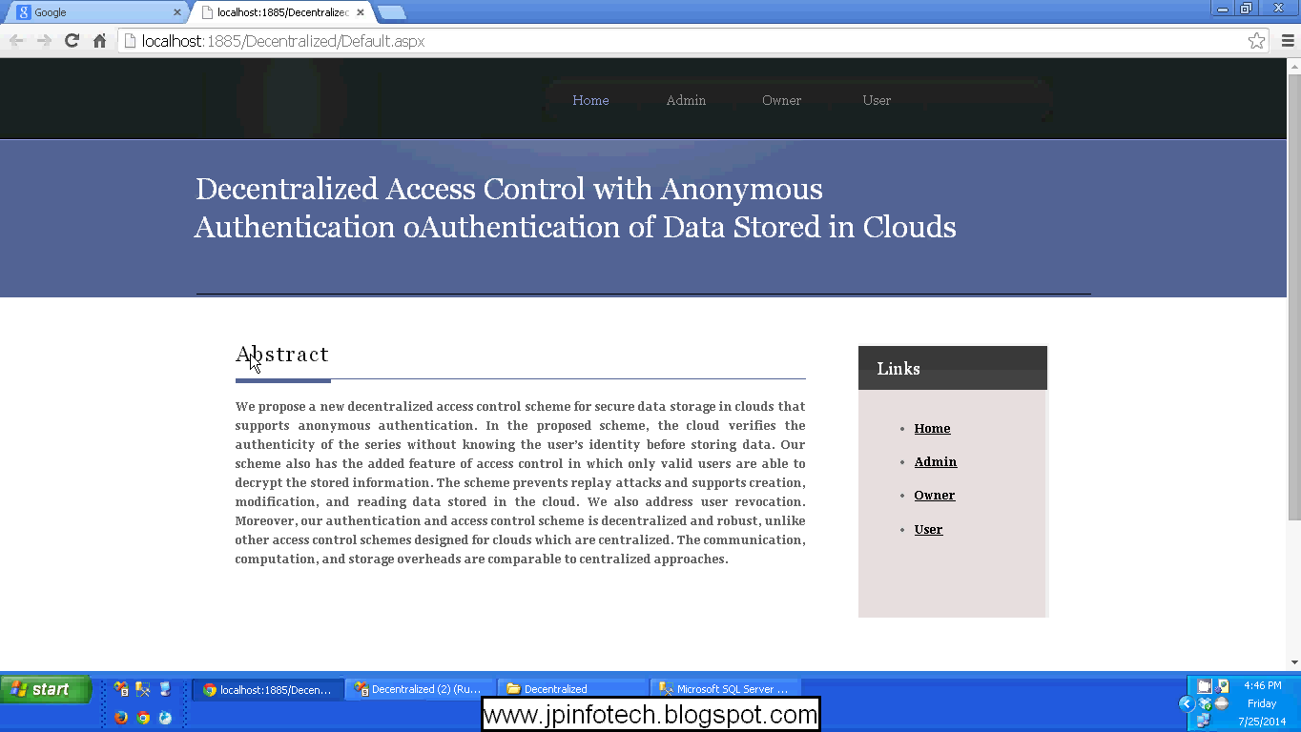

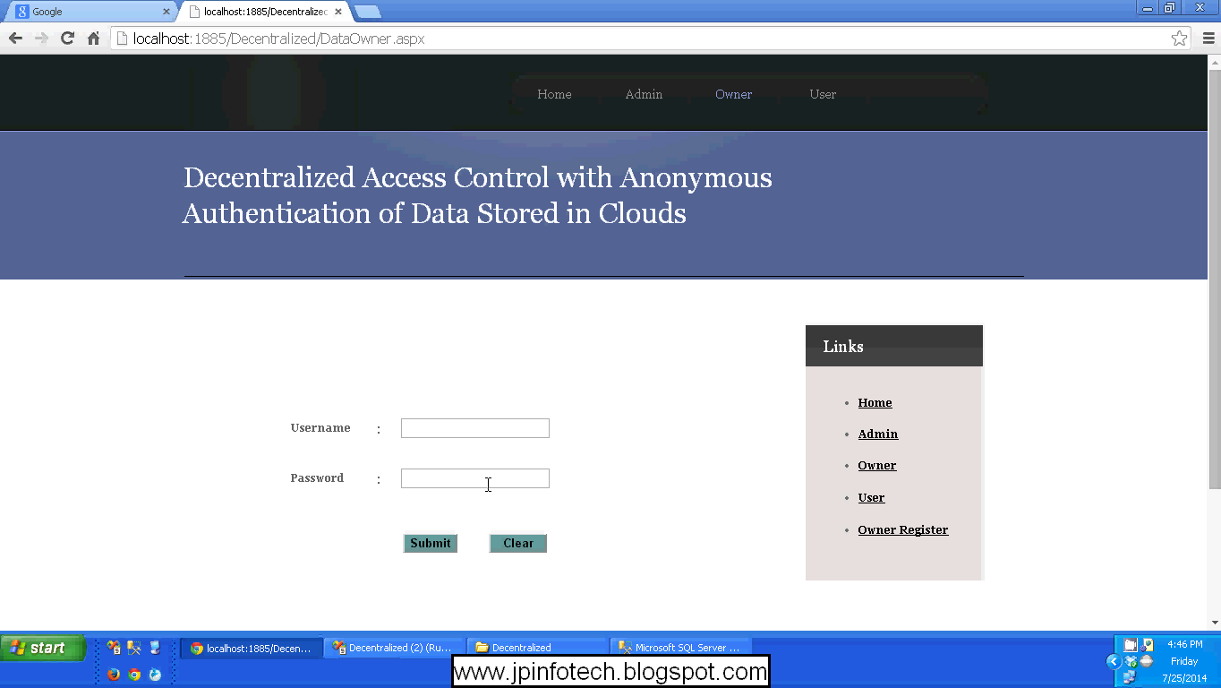

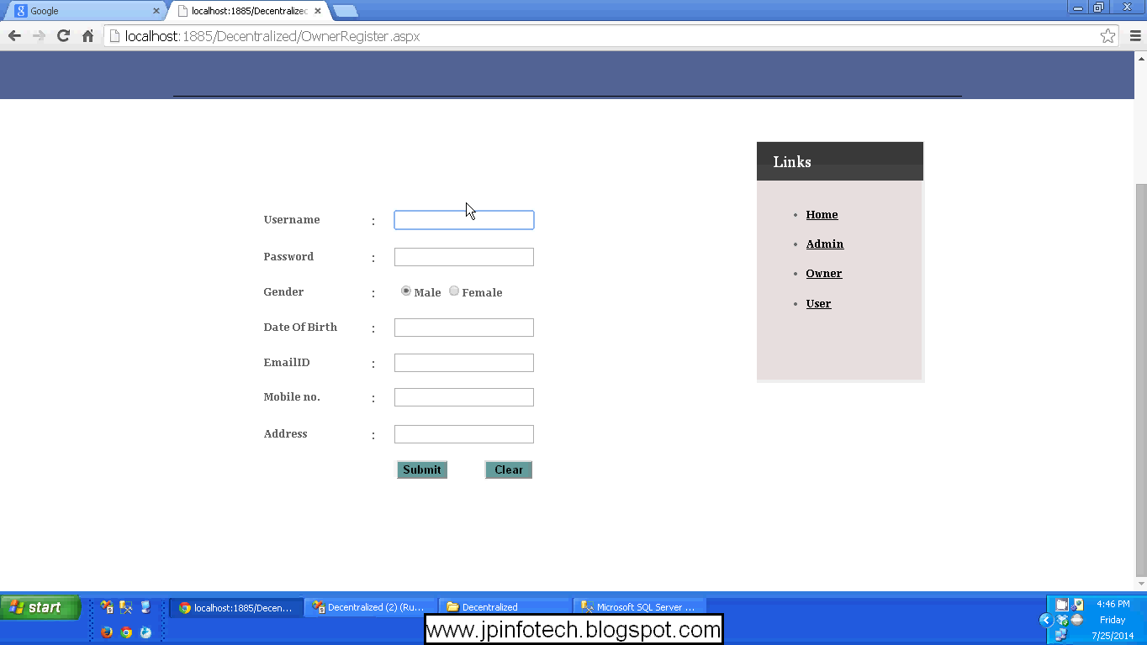

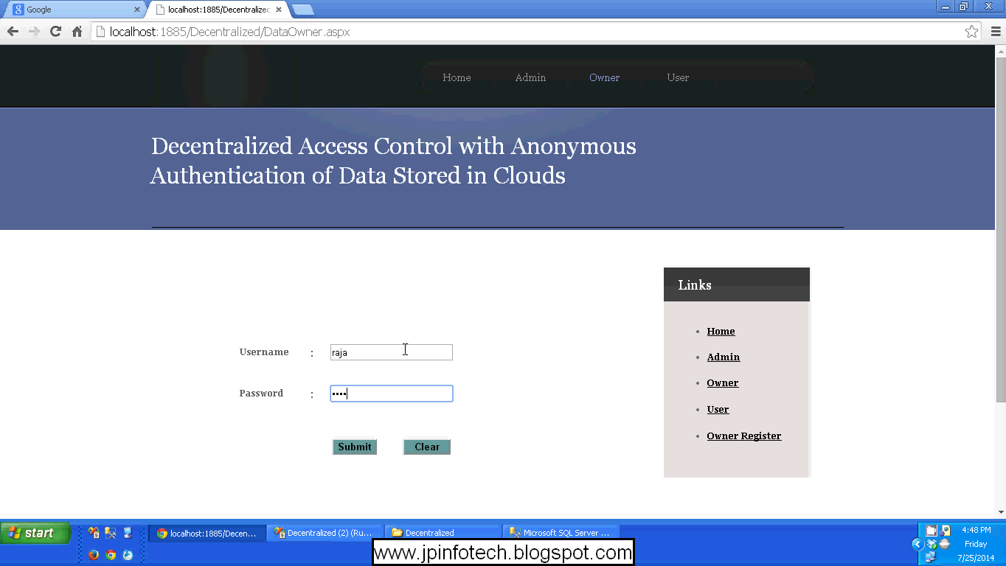

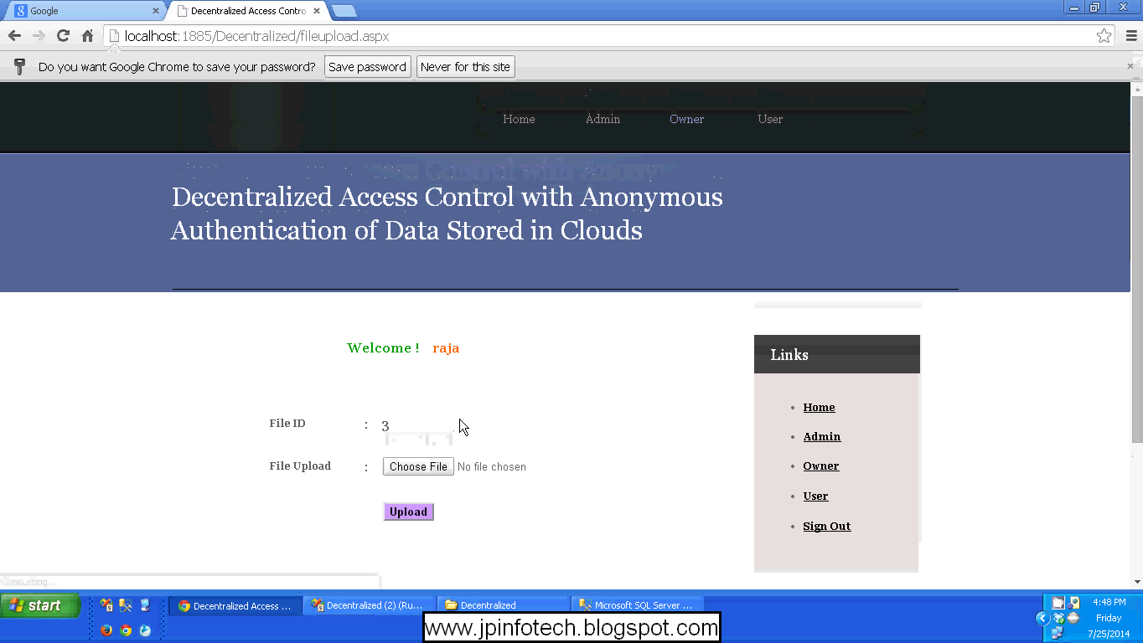

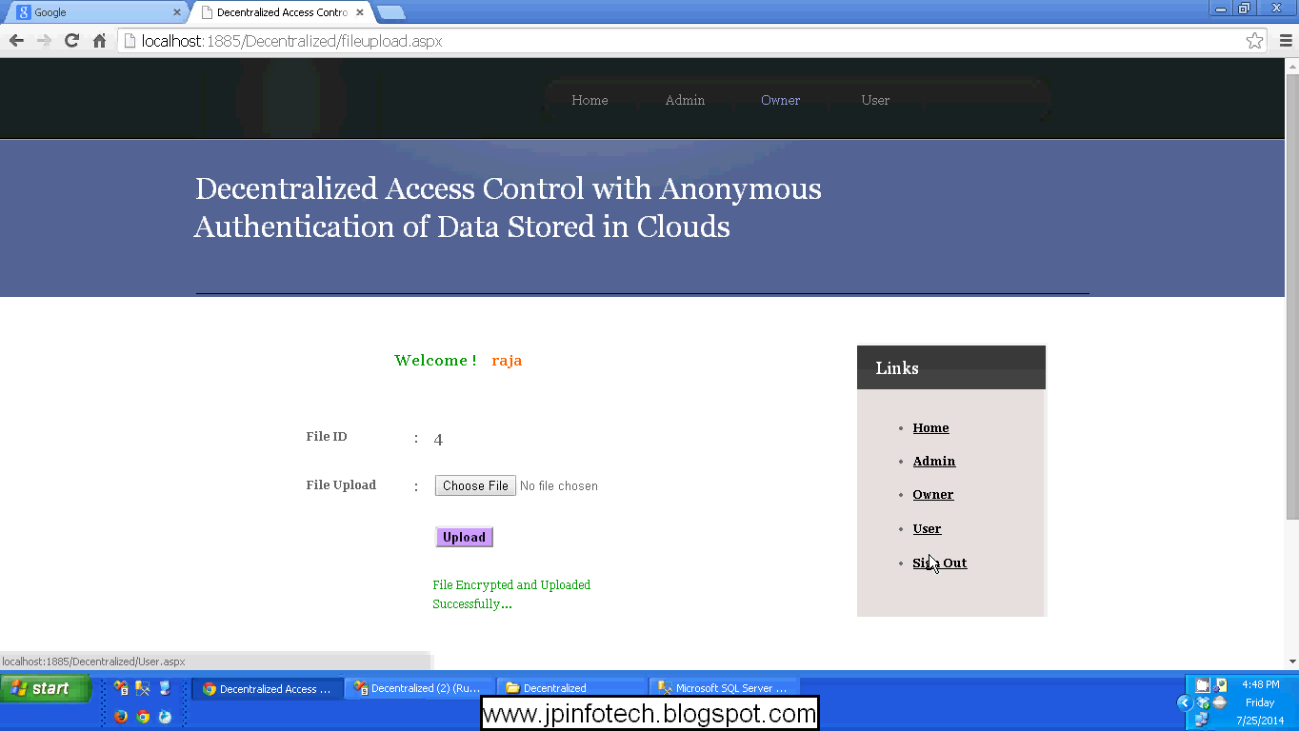

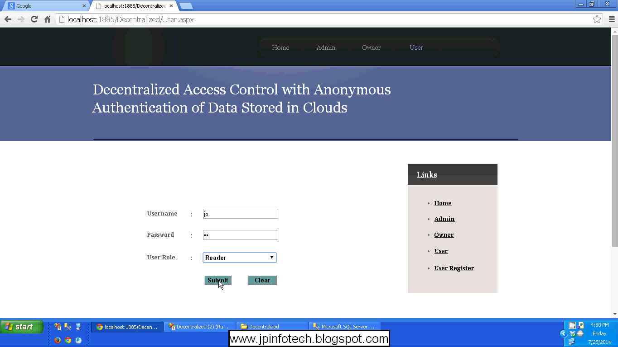

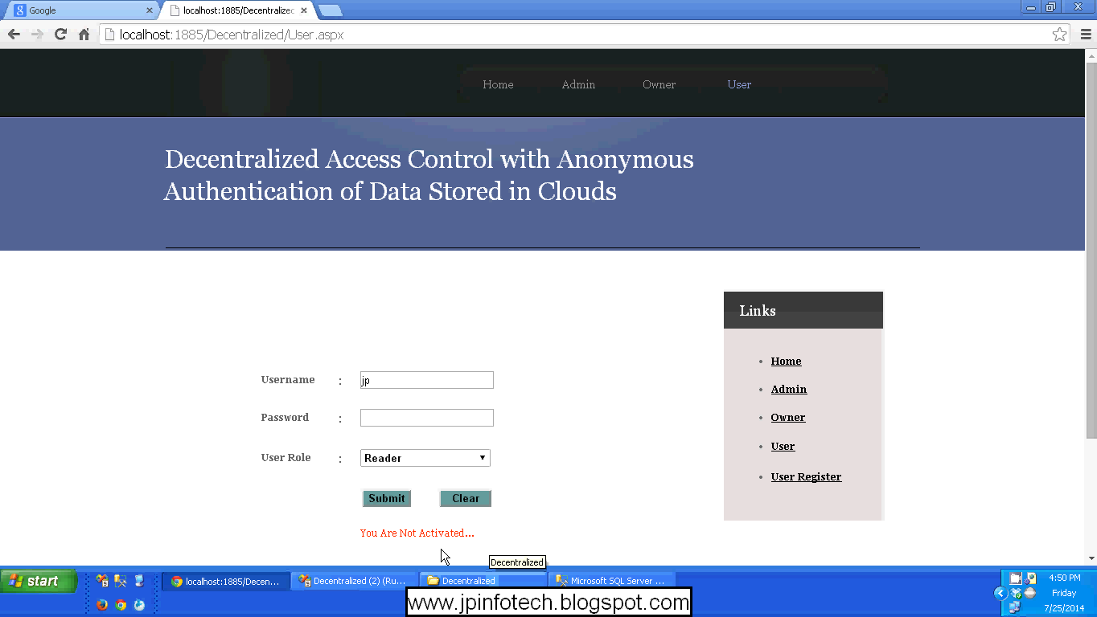

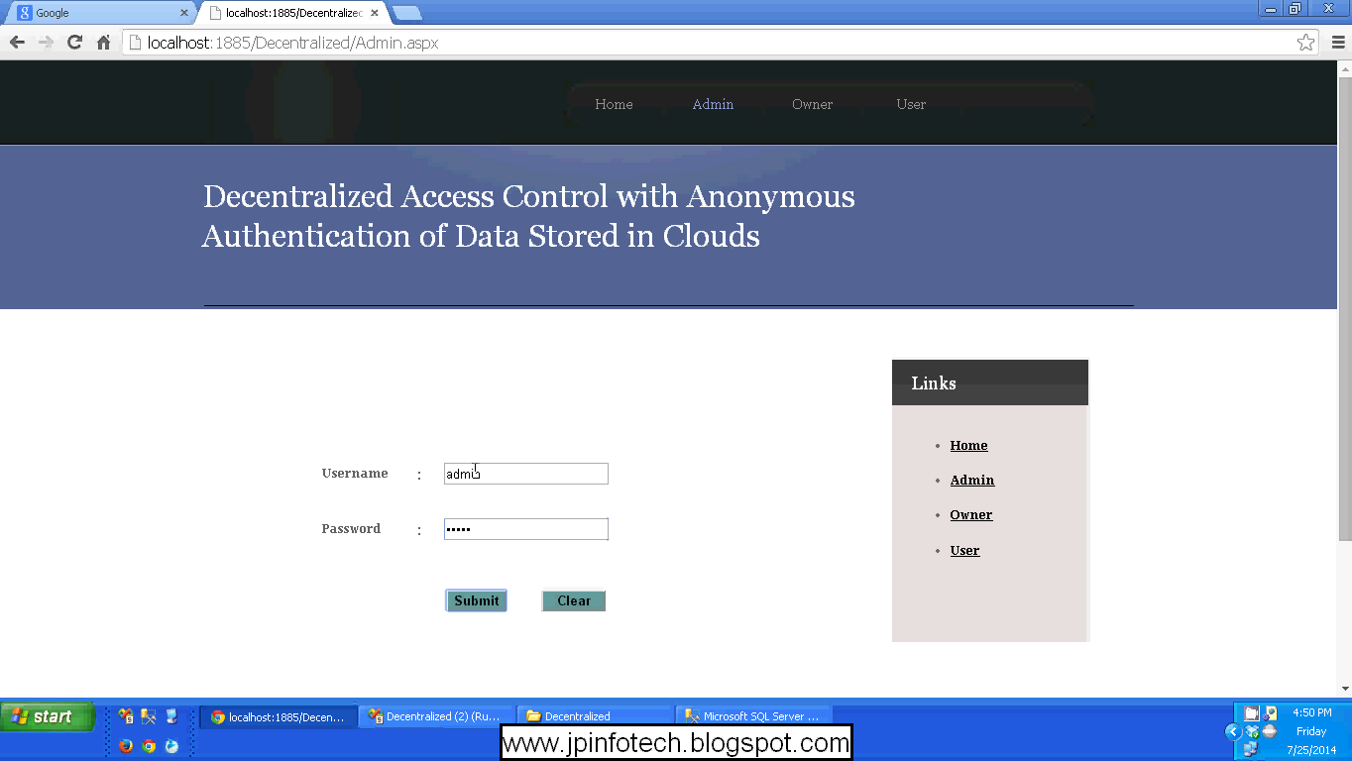

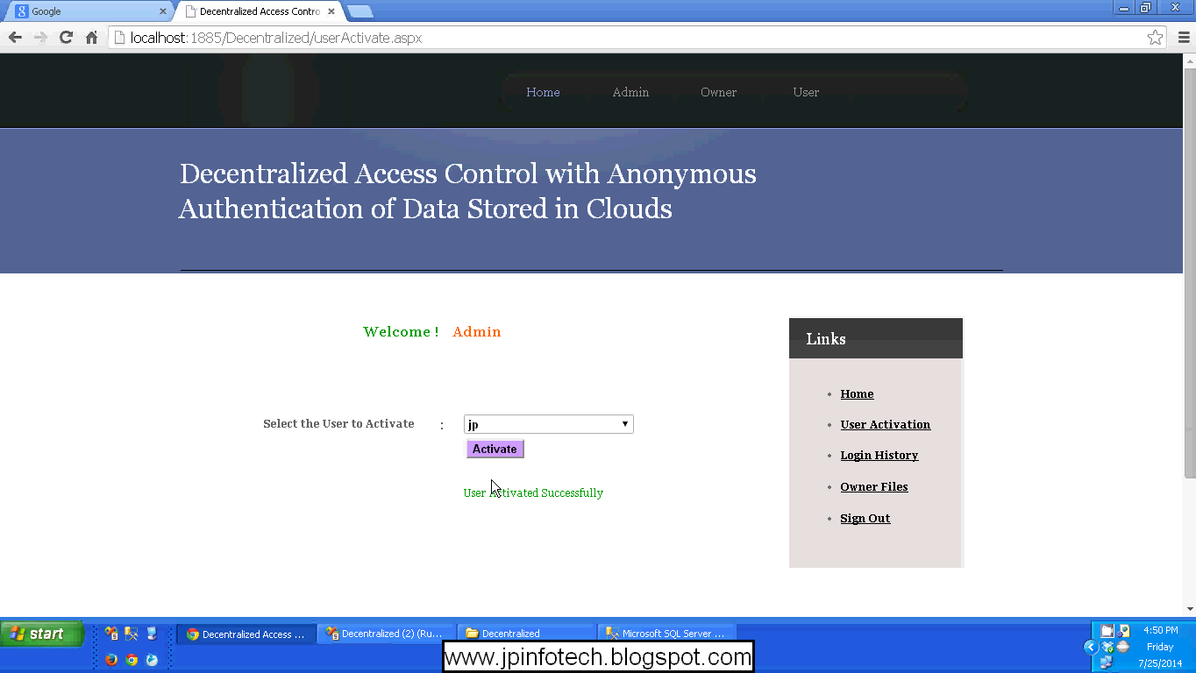

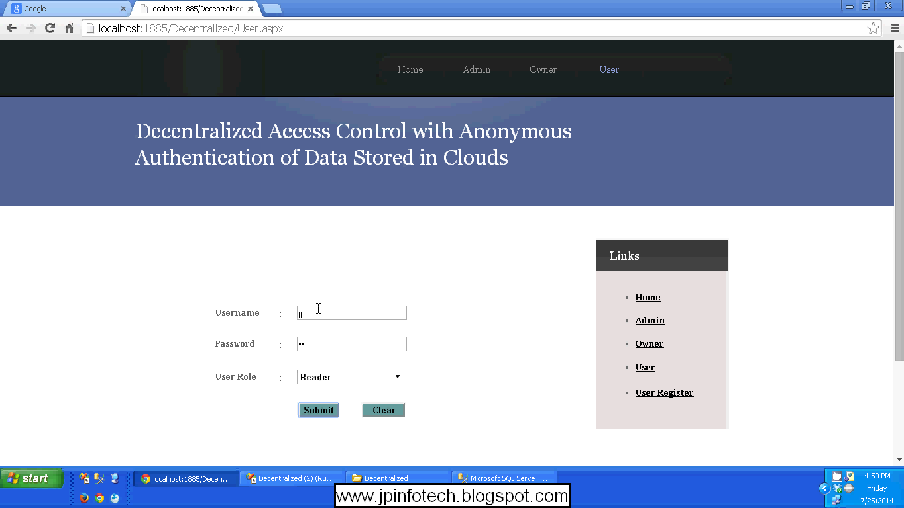

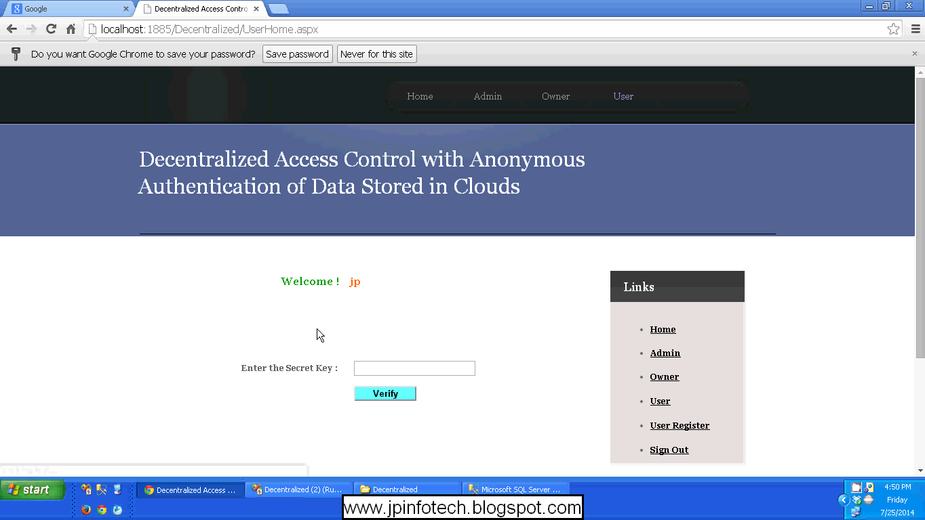

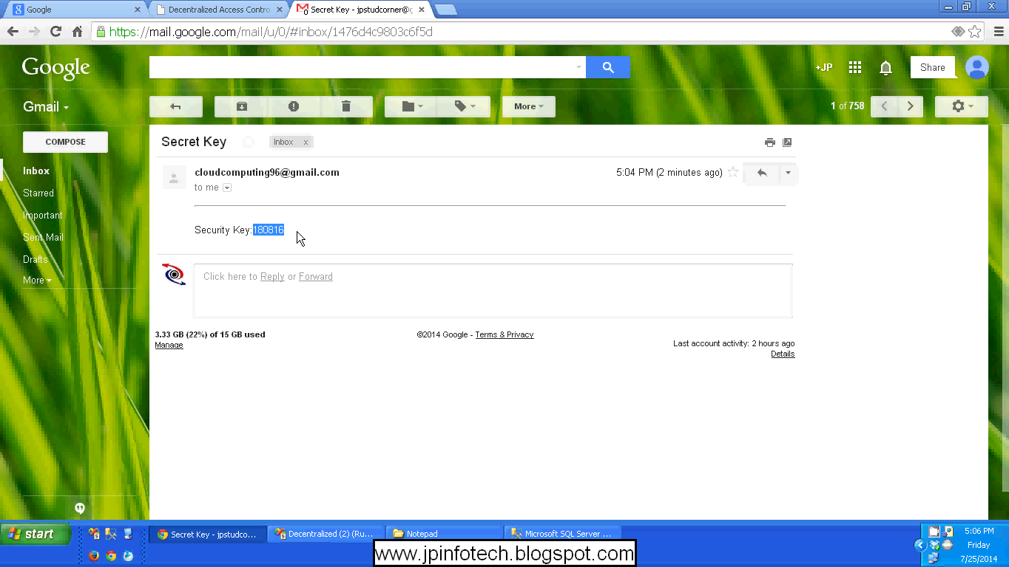

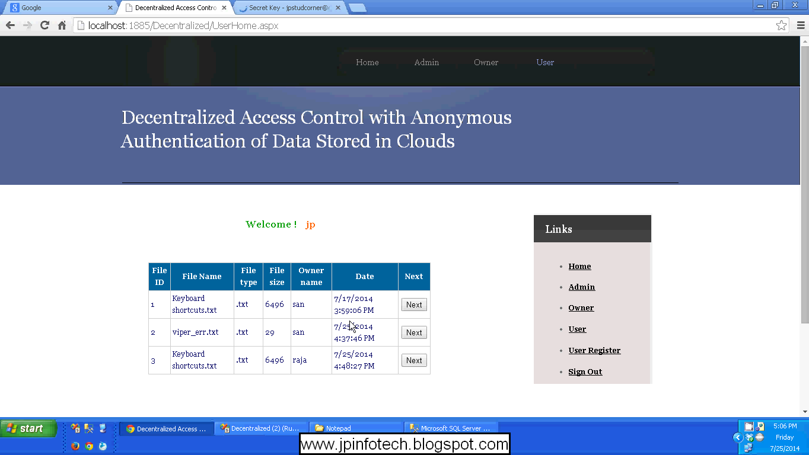

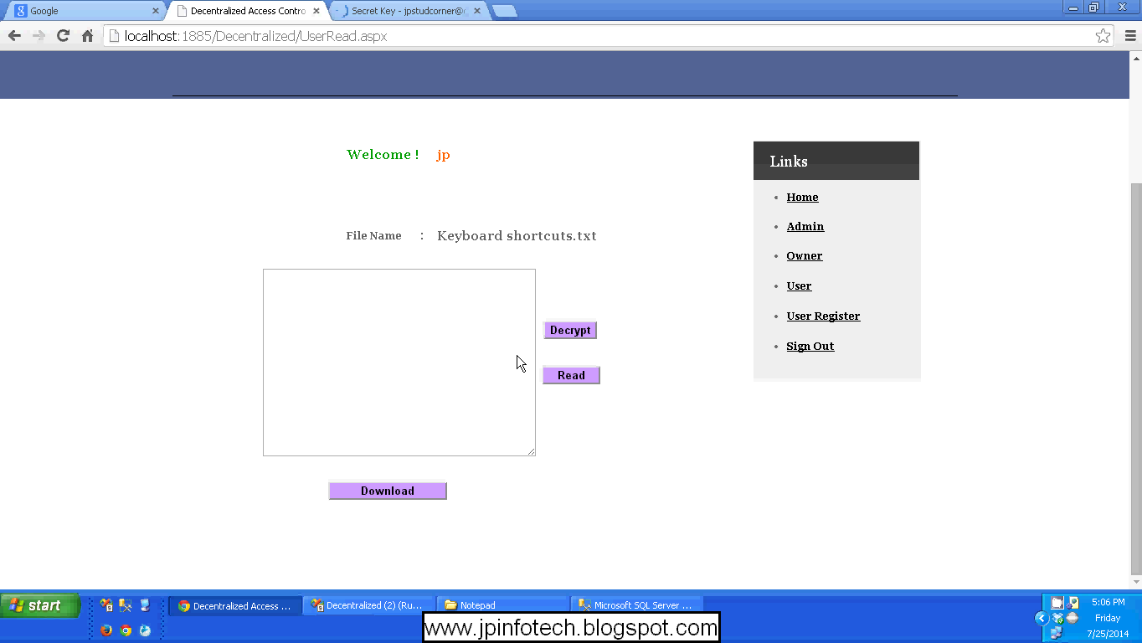

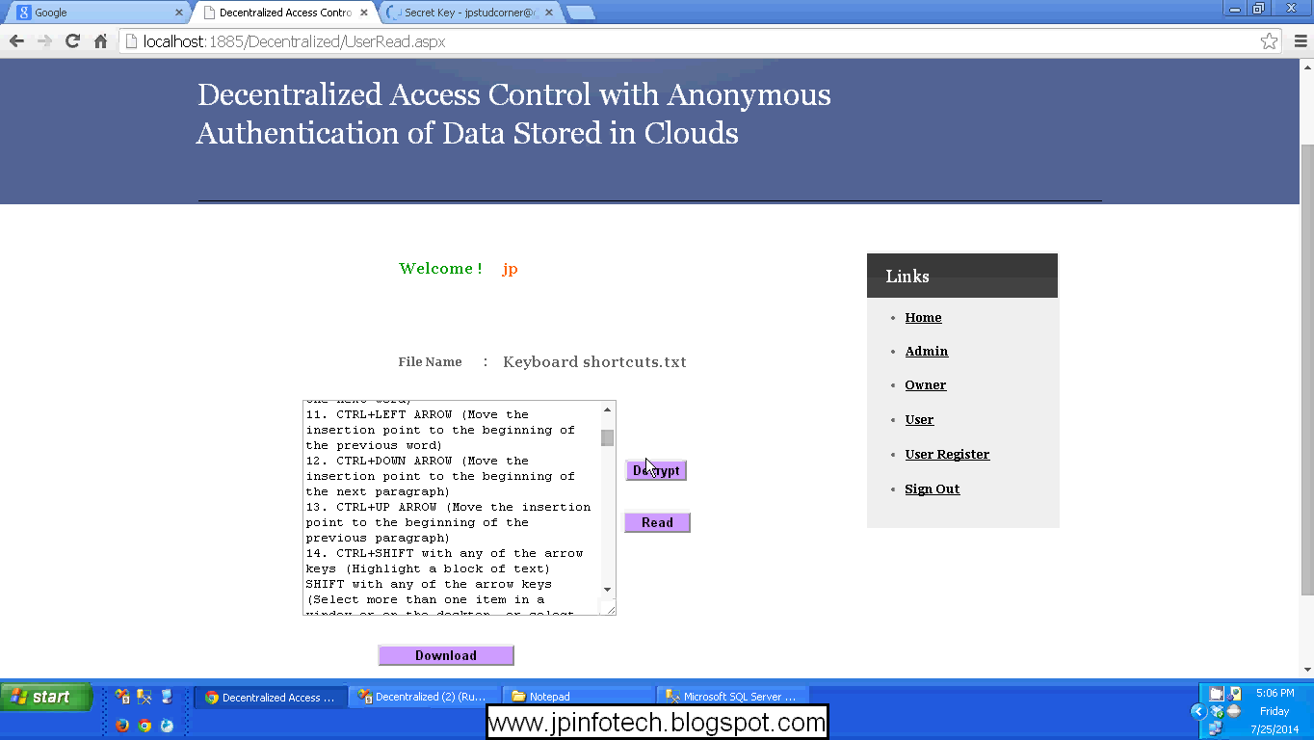

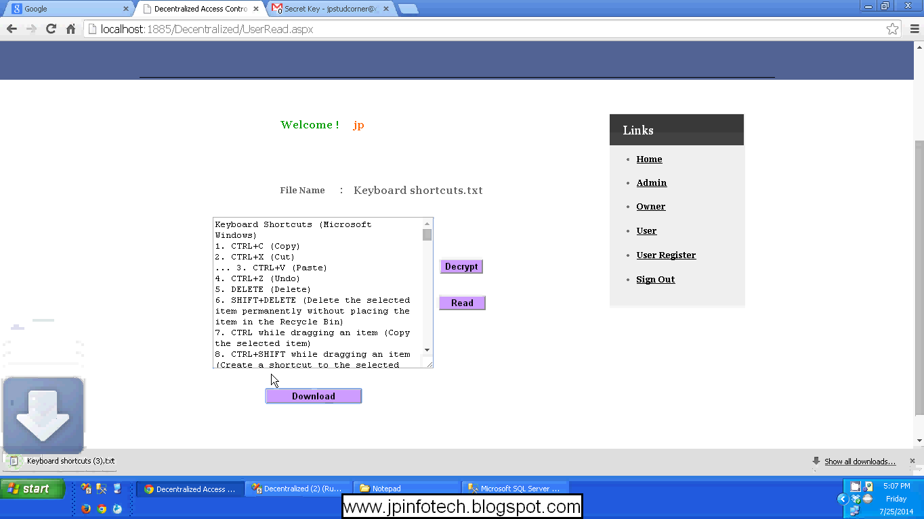

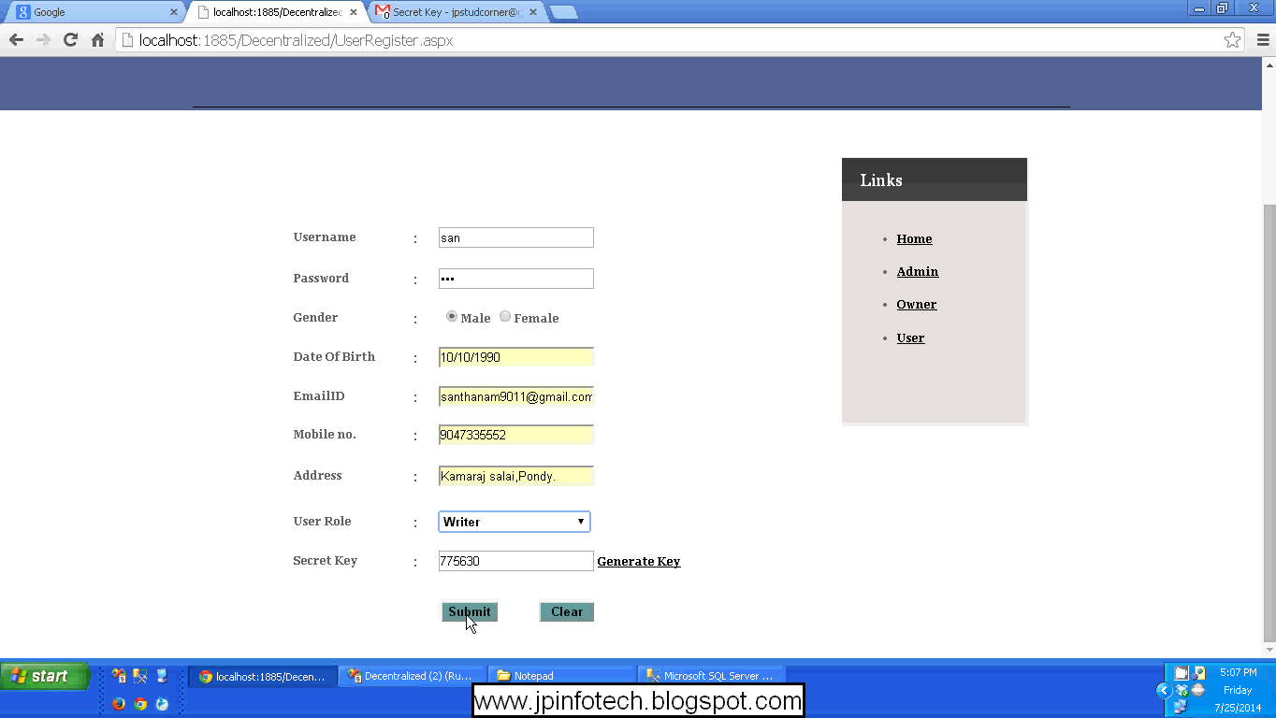
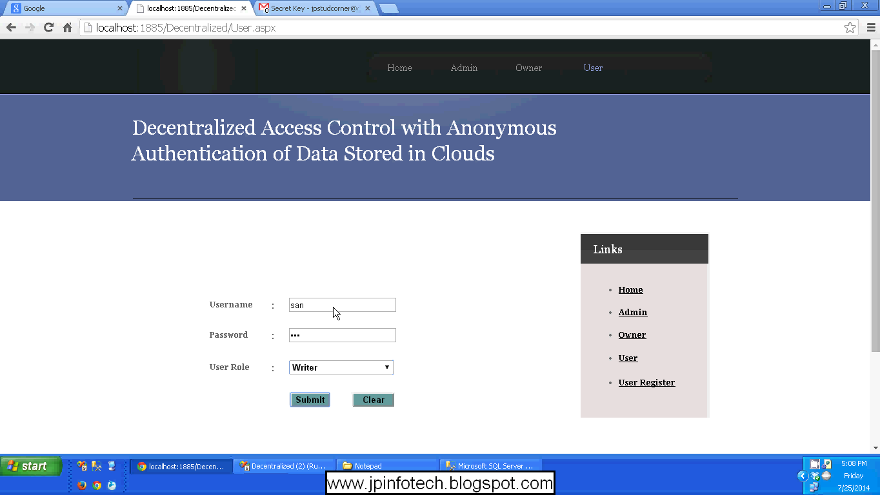

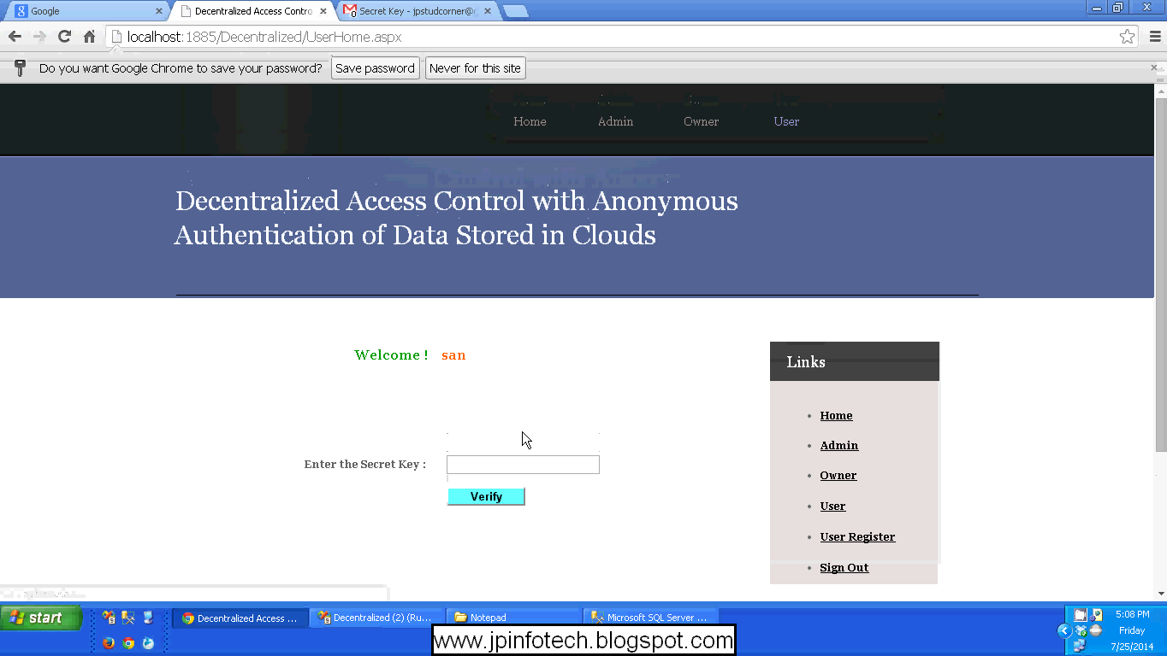
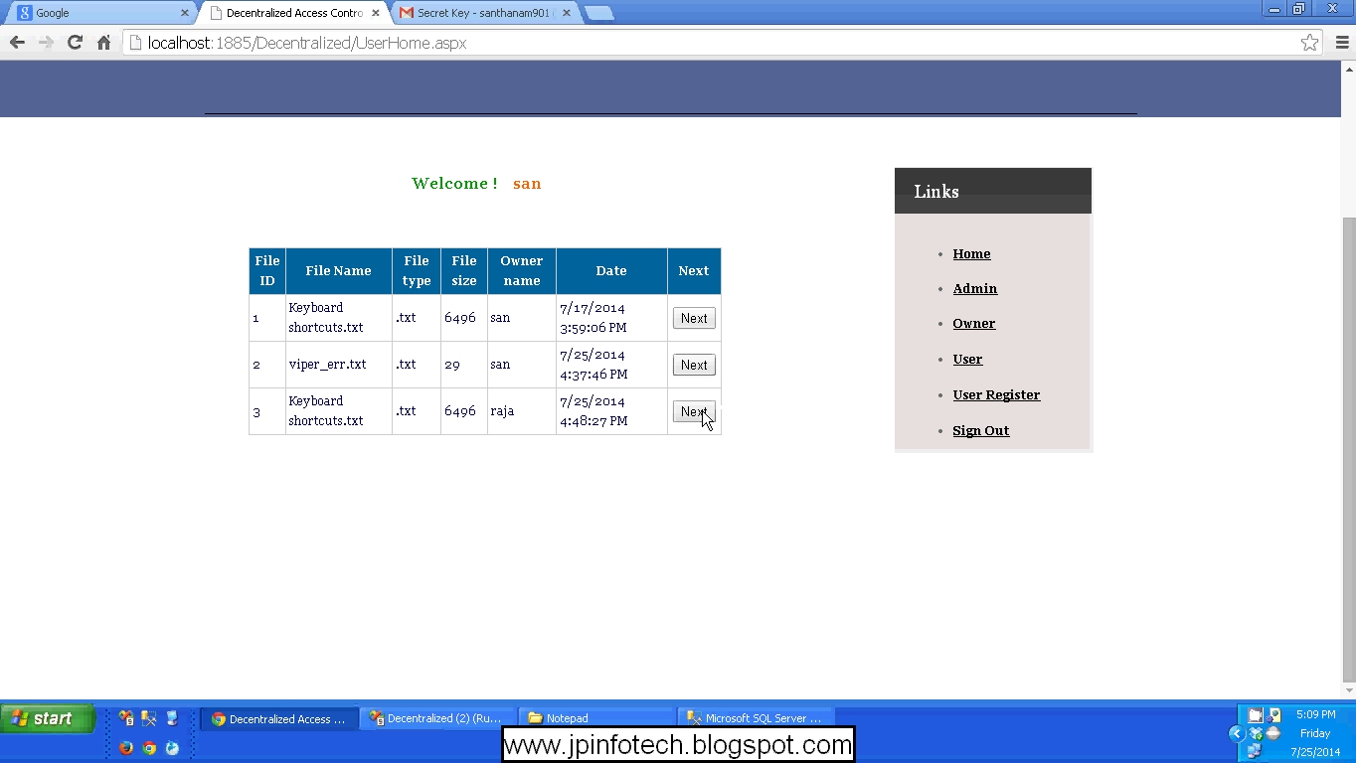

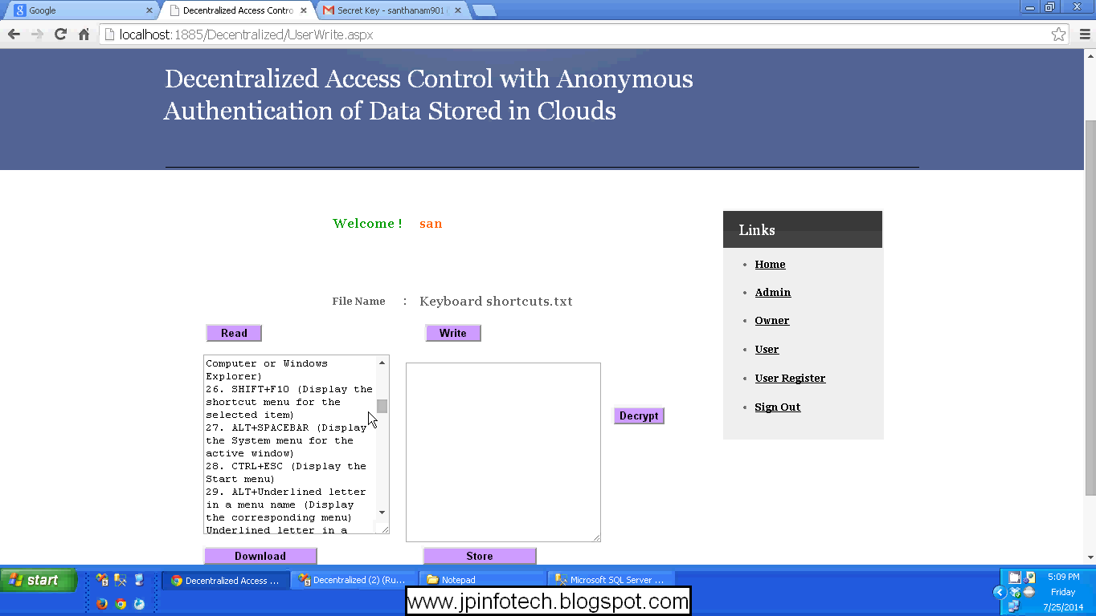

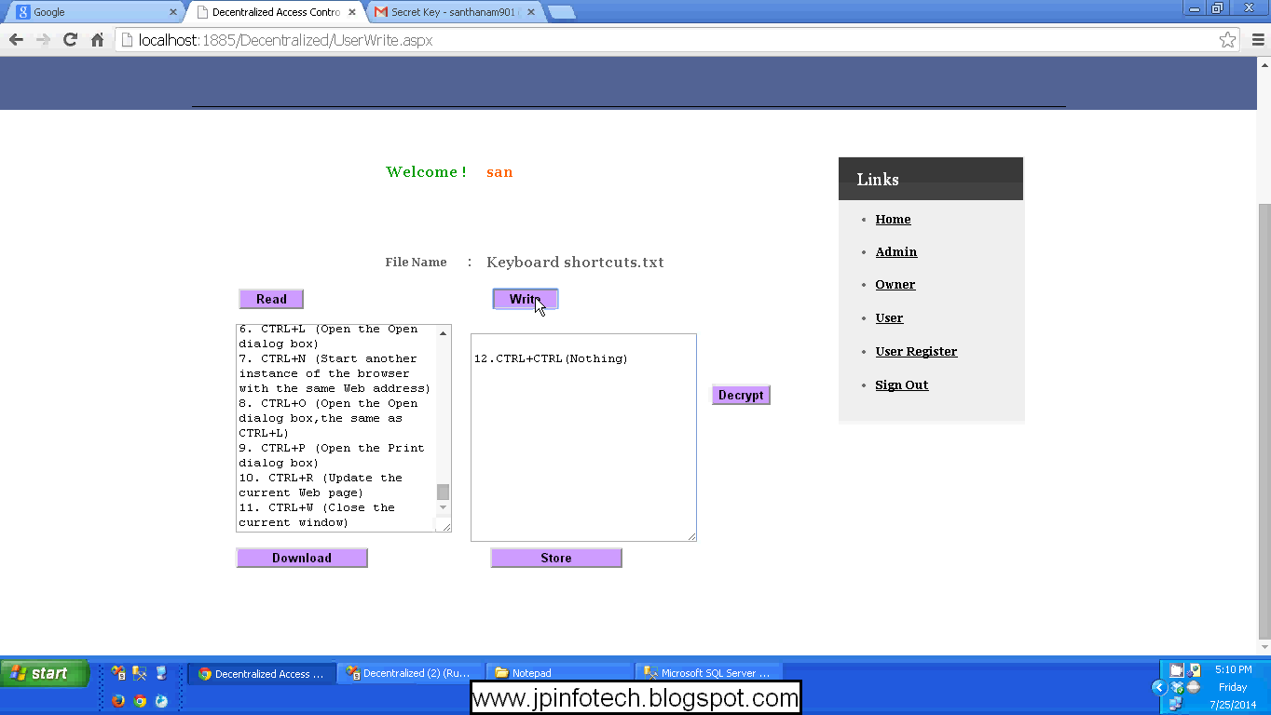
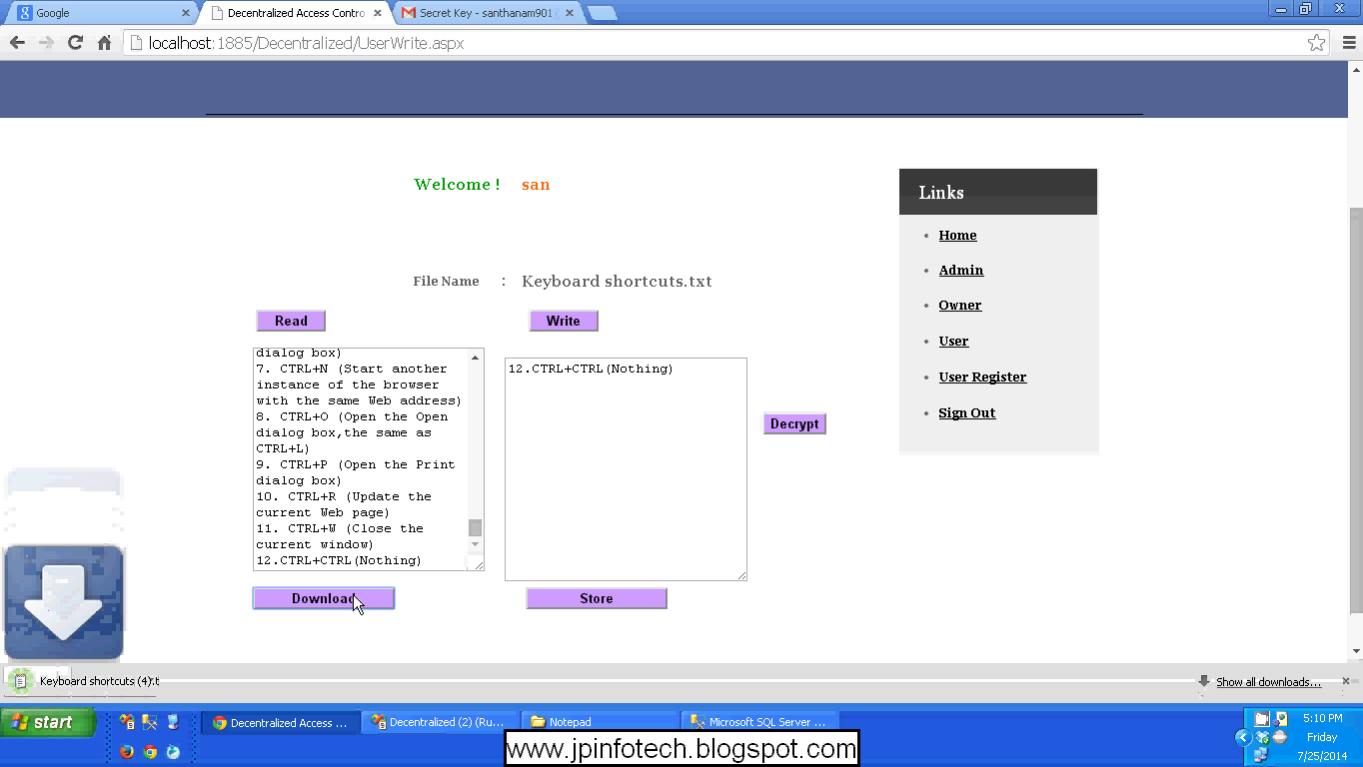

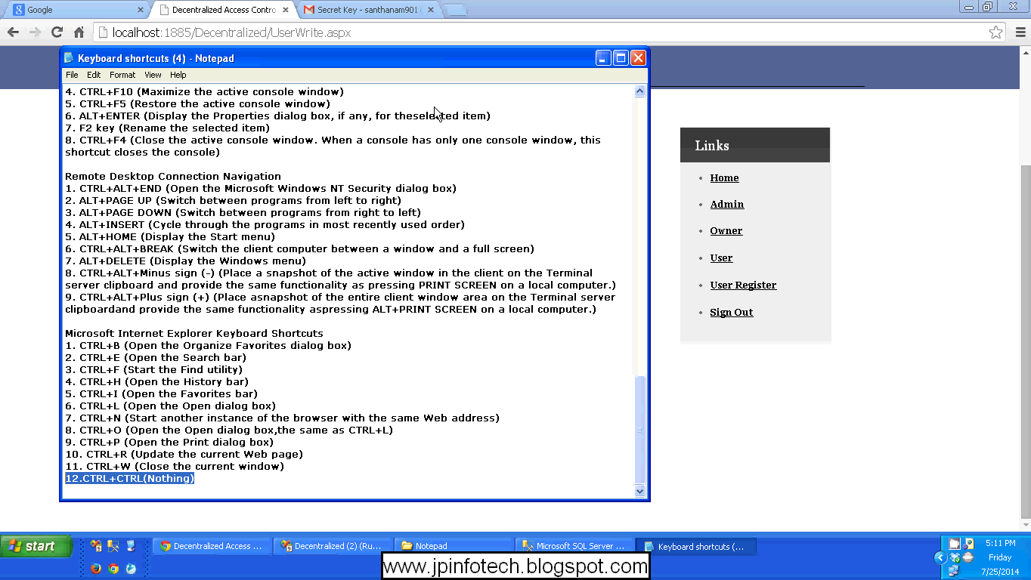
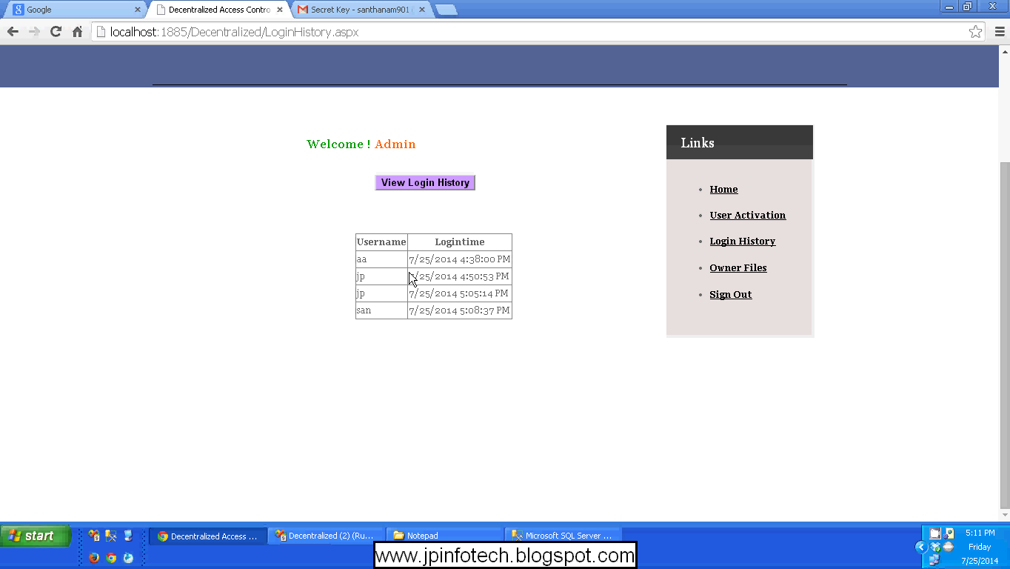

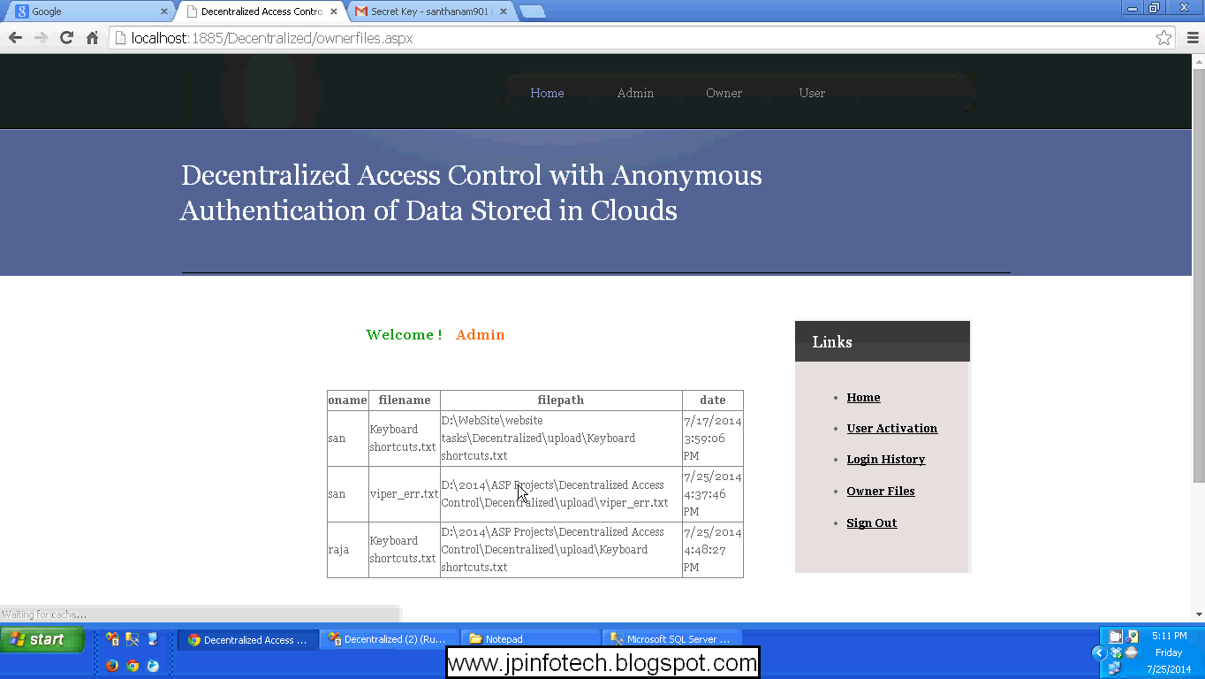

10.2. SAMPLE CODING

User
using System;
using System.Collections.Generic;
using System.Linq;
using System.Web;
using System.Web.UI;
using System.Web.UI.WebControls;
using System.Data.SqlClient;
using System.Configuration;

publicpartialclassuserActivate : System.Web.UI.Page
{
SqlConnection con = newSqlConnection(ConfigurationManager.ConnectionStrings["DeConnection"].ConnectionString);
protectedvoid Page_Load(object sender, EventArgs e)
{

}
protectedvoid Button1_Click(object sender, EventArgs e)
{
string uname = DropDownList1.SelectedItem.ToString();
con.Open();
SqlCommand cmd = newSqlCommand("update UserReg set Activate = 'YES' where Username = '"+uname+"'",con);
cmd.ExecuteNonQuery();
con.Close();
Label12.Text = "User Activated Successfully";
}
protectedvoid DropDownList1_SelectedIndexChanged(object sender, EventArgs e)
{

}
}
User read
using System;
using System.Collections.Generic;
using System.Linq;
using System.Web;
using System.Web.UI;
using System.Web.UI.WebControls;
using System.IO;
using System.Text;
using System.Security;
using System.Security.Cryptography;
using System.Runtime.InteropServices;
using System.Text.RegularExpressions;

publicpartialclassUserRead : System.Web.UI.Page
{
protectedvoid Page_Load(object sender, EventArgs e)
{
Label11.Text = Session["username"].ToString();
Label12.Text = Session["fname"].ToString();
}
protectedvoid Button1_Click(object sender, EventArgs e)
{
string filename = Server.MapPath("~/decrypt/") + Label12.Text;
FileInfo fileInfo = newFileInfo(filename);

if (fileInfo.Exists)
{
Response.Clear();
Response.AddHeader("Content-Disposition", "attachment; filename=" + fileInfo.Name);
Response.AddHeader("Content-Length", fileInfo.Length.ToString());
Response.ContentType = "application/octet-stream";
Response.Flush();
Response.WriteFile(fileInfo.FullName);
Response.End();
}
}
privatevoid DecryptFile(string inputFile, string outputFile)
{
try
{
string password = @"myKey123"; // Your Key Here

UnicodeEncoding UE = newUnicodeEncoding();
byte[] key = UE.GetBytes(password);

FileStream fsCrypt = newFileStream(inputFile, FileMode.Open);

RijndaelManaged RMCrypto = newRijndaelManaged();

CryptoStream cs = newCryptoStream(fsCrypt,
RMCrypto.CreateDecryptor(key, key),
CryptoStreamMode.Read);

FileStream fsOut = newFileStream(outputFile, FileMode.Create);

int data;
while ((data = cs.ReadByte()) != -1)
fsOut.WriteByte((byte)data);

fsOut.Close();
cs.Close();
fsCrypt.Close();

}
catch { }
}
protectedvoid Button2_Click(object sender, EventArgs e)
{
string encfil = Server.MapPath("~/encrypt/") + Label12.Text;
string decfil = Server.MapPath("~/decrypt/") + Label12.Text;
DecryptFile(encfil, decfil);
Button3.Enabled = true;
}
protectedvoid Button3_Click(object sender, EventArgs e)
{
if (File.Exists(Server.MapPath("~/decrypt/") + Label12.Text))
{
TextBox1.Text = File.ReadAllText(Server.MapPath("~/decrypt/") + Label12.Text);
}
else
{
TextBox1.Text = File.ReadAllText(Server.MapPath("~/encrypt/") + Label12.Text);
}
Button1.Enabled = true;
}
}
Data owner
using System;
using System.Collections.Generic;
using System.Linq;
using System.Web;
using System.Web.UI;
using System.Web.UI.WebControls;
using System.Data.SqlClient;
using System.Configuration;

publicpartialclassDataOwner : System.Web.UI.Page
{
SqlConnection con = newSqlConnection(ConfigurationManager.ConnectionStrings["DeConnection"].ConnectionString);
protectedvoid Page_Load(object sender, EventArgs e)
{

}
protectedvoid Button1_Click(object sender, EventArgs e)
{
con.Open();
SqlCommand cmd = newSqlCommand("select Username from OwnerReg where Username = '" + TextBox1.Text + "'", con);
SqlCommand cmd1 = newSqlCommand("select Password from OwnerReg where Username = '" + TextBox1.Text + "'", con);
string uname = (string)cmd.ExecuteScalar();
string pwd = (string)cmd1.ExecuteScalar();
con.Close();

if (TextBox1.Text == uname && TextBox2.Text == pwd)
{
Session["ownername"] = TextBox1.Text;
Response.Redirect("fileupload.aspx");
}
else
{
Label17.Text = "Invalid Details...";
}
}
protectedvoid Button2_Click(object sender, EventArgs e)
{
TextBox1.Text = "";
TextBox2.Text = "";
}
}

WEB CONFIG
<?xmlversion="1.0"?>
<!--
Note: As an alternative to hand editing this file you can use the
web admin tool to configure settings for your application. Use
the Website->Asp.Net Configuration option in Visual Studio.
A full list of settings and comments can be found in
machine.config.comments usually located in
\Windows\Microsoft.Net\Framework\v2.x\Config
-->
<configuration>
<configSections>
<sectionGroupname="system.web.extensions"type="System.Web.Configuration.SystemWebExtensionsSectionGroup, System.Web.Extensions, Version=3.5.0.0, Culture=neutral, PublicKeyToken=31BF3856AD364E35">
<sectionGroupname="scripting"type="System.Web.Configuration.ScriptingSectionGroup, System.Web.Extensions, Version=3.5.0.0, Culture=neutral, PublicKeyToken=31BF3856AD364E35">
<sectionname="scriptResourceHandler"type="System.Web.Configuration.ScriptingScriptResourceHandlerSection, System.Web.Extensions, Version=3.5.0.0, Culture=neutral, PublicKeyToken=31BF3856AD364E35"requirePermission="false"allowDefinition="MachineToApplication"/>
<sectionGroupname="webServices"type="System.Web.Configuration.ScriptingWebServicesSectionGroup, System.Web.Extensions, Version=3.5.0.0, Culture=neutral, PublicKeyToken=31BF3856AD364E35">
<sectionname="jsonSerialization"type="System.Web.Configuration.ScriptingJsonSerializationSection, System.Web.Extensions, Version=3.5.0.0, Culture=neutral, PublicKeyToken=31BF3856AD364E35"requirePermission="false"allowDefinition="Everywhere"/>
<sectionname="profileService"type="System.Web.Configuration.ScriptingProfileServiceSection, System.Web.Extensions, Version=3.5.0.0, Culture=neutral, PublicKeyToken=31BF3856AD364E35"requirePermission="false"allowDefinition="MachineToApplication"/>
<sectionname="authenticationService"type="System.Web.Configuration.ScriptingAuthenticationServiceSection, System.Web.Extensions, Version=3.5.0.0, Culture=neutral, PublicKeyToken=31BF3856AD364E35"requirePermission="false"allowDefinition="MachineToApplication"/>
<sectionname="roleService"type="System.Web.Configuration.ScriptingRoleServiceSection, System.Web.Extensions, Version=3.5.0.0, Culture=neutral, PublicKeyToken=31BF3856AD364E35"requirePermission="false"allowDefinition="MachineToApplication"/>
</sectionGroup>
</sectionGroup>
</sectionGroup>
</configSections>
<appSettings/>
<connectionStrings>
<addname="DeConnection"connectionString="Data Source=.\SQLEXPRESS;Initial Catalog=Decentralized;Integrated Security=True"providerName="System.Data.SqlClient"/>
</connectionStrings>
<system.web>
<!--
Set compilation debug="true" to insert debugging
symbols into the compiled page. Because this
affects performance, set this value to true only
during development.
-->
<compilationdebug="true">
<assemblies>
<addassembly="System.Core, Version=3.5.0.0, Culture=neutral, PublicKeyToken=B77A5C561934E089"/>
<addassembly="System.Web.Extensions, Version=3.5.0.0, Culture=neutral, PublicKeyToken=31BF3856AD364E35"/>
<addassembly="System.Data.DataSetExtensions, Version=3.5.0.0, Culture=neutral, PublicKeyToken=B77A5C561934E089"/>
<addassembly="System.Xml.Linq, Version=3.5.0.0, Culture=neutral, PublicKeyToken=B77A5C561934E089"/>
</assemblies>
</compilation>
<!--
The <authentication> section enables configuration
of the security authentication mode used by
ASP.NET to identify an incoming user.
-->
<authenticationmode="Windows"/>
<!--
The <customErrors> section enables configuration
of what to do if/when an unhandled error occurs
during the execution of a request. Specifically,
it enables developers to configure html error pages
to be displayed in place of a error stack trace.

<customErrors mode="RemoteOnly" defaultRedirect="GenericErrorPage.htm">
<error statusCode="403" redirect="NoAccess.htm" />
<error statusCode="404" redirect="FileNotFound.htm" />
</customErrors>
-->
<pagesvalidateRequest="false">
<controls>
<addtagPrefix="asp"namespace="System.Web.UI"assembly="System.Web.Extensions, Version=3.5.0.0, Culture=neutral, PublicKeyToken=31BF3856AD364E35"/>
<addtagPrefix="asp"namespace="System.Web.UI.WebControls"assembly="System.Web.Extensions, Version=3.5.0.0, Culture=neutral, PublicKeyToken=31BF3856AD364E35"/>
</controls>
</pages>
<httpHandlers>
<removeverb="*"path="*.asmx"/>
<addverb="*"path="*.asmx"validate="false"type="System.Web.Script.Services.ScriptHandlerFactory, System.Web.Extensions, Version=3.5.0.0, Culture=neutral, PublicKeyToken=31BF3856AD364E35"/>
<addverb="*"path="*_AppService.axd"validate="false"type="System.Web.Script.Services.ScriptHandlerFactory, System.Web.Extensions, Version=3.5.0.0, Culture=neutral, PublicKeyToken=31BF3856AD364E35"/>
<addverb="GET,HEAD"path="ScriptResource.axd"type="System.Web.Handlers.ScriptResourceHandler, System.Web.Extensions, Version=3.5.0.0, Culture=neutral, PublicKeyToken=31BF3856AD364E35"validate="false"/>
</httpHandlers>
<httpModules>
<addname="ScriptModule"type="System.Web.Handlers.ScriptModule, System.Web.Extensions, Version=3.5.0.0, Culture=neutral, PublicKeyToken=31BF3856AD364E35"/>
</httpModules>
</system.web>
<system.codedom>
<compilers>
<compilerlanguage="c#;cs;csharp"extension=".cs"warningLevel="4"type="Microsoft.CSharp.CSharpCodeProvider, System, Version=2.0.0.0, Culture=neutral, PublicKeyToken=b77a5c561934e089">
<providerOptionname="CompilerVersion"value="v3.5"/>
<providerOptionname="WarnAsError"value="false"/>
</compiler>
<compilerlanguage="vb;vbs;visualbasic;vbscript"extension=".vb"warningLevel="4"type="Microsoft.VisualBasic.VBCodeProvider, System, Version=2.0.0.0, Culture=neutral, PublicKeyToken=b77a5c561934e089">
<providerOptionname="CompilerVersion"value="v3.5"/>
<providerOptionname="OptionInfer"value="true"/>
<providerOptionname="WarnAsError"value="false"/>
</compiler>
</compilers>
</system.codedom>
<!--
The system.webServer section is required for running ASP.NET AJAX under Internet
Information Services 7.0. It is not necessary for previous version of IIS.
-->
<system.webServer>
<validationvalidateIntegratedModeConfiguration="false"/>
<modules>
<removename="ScriptModule"/>
<addname="ScriptModule"preCondition="managedHandler"type="System.Web.Handlers.ScriptModule, System.Web.Extensions, Version=3.5.0.0, Culture=neutral, PublicKeyToken=31BF3856AD364E35"/>
</modules>
<handlers>
<removename="WebServiceHandlerFactory-Integrated"/>
<removename="ScriptHandlerFactory"/>
<removename="ScriptHandlerFactoryAppServices"/>
<removename="ScriptResource"/>
<addname="ScriptHandlerFactory"verb="*"path="*.asmx"preCondition="integratedMode"type="System.Web.Script.Services.ScriptHandlerFactory, System.Web.Extensions, Version=3.5.0.0, Culture=neutral, PublicKeyToken=31BF3856AD364E35"/>
<addname="ScriptHandlerFactoryAppServices"verb="*"path="*_AppService.axd"preCondition="integratedMode"type="System.Web.Script.Services.ScriptHandlerFactory, System.Web.Extensions, Version=3.5.0.0, Culture=neutral, PublicKeyToken=31BF3856AD364E35"/>
<addname="ScriptResource"preCondition="integratedMode"verb="GET,HEAD"path="ScriptResource.axd"type="System.Web.Handlers.ScriptResourceHandler, System.Web.Extensions, Version=3.5.0.0, Culture=neutral, PublicKeyToken=31BF3856AD364E35"/>
</handlers>
</system.webServer>
<runtime>
<assemblyBindingxmlns="urn:schemas-microsoft-com:asm.v1">
<dependentAssembly>
<assemblyIdentityname="System.Web.Extensions"publicKeyToken="31bf3856ad364e35"/>
<bindingRedirectoldVersion="1.0.0.0-1.1.0.0"newVersion="3.5.0.0"/>
</dependentAssembly>
<dependentAssembly>
<assemblyIdentityname="System.Web.Extensions.Design"publicKeyToken="31bf3856ad364e35"/>
<bindingRedirectoldVersion="1.0.0.0-1.1.0.0"newVersion="3.5.0.0"/>
</dependentAssembly>
</assemblyBinding>
</runtime>
</configuration>

